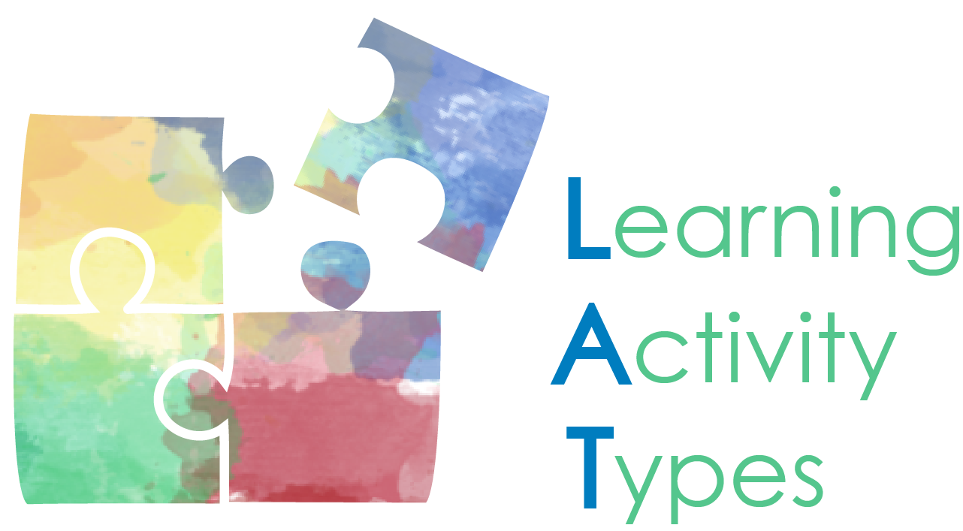 | LAT Short Course Instructor Guide  Version 1, 3/8/2016

Table of Contents
Introduction to the Short Course 1
Overview of Course 2
Teaching Tips 4
How to Use the Materials 4
Questions/Comments/Suggestions 5
Contact the Authors 6
References 6

Introduction to the Short Course

Preparing novice teachers to use digital technologies effectively in teaching is no small undertaking. The publication of the TPCK and TPACK frameworks (Angeli & Valanides, 2005; Mishra & Koehler, 2006; Niess, 2005) focused and increased efforts to assist novice teachers in building their knowledge for curriculum-based approaches to technology integration.

We have used curriculum-keyed taxonomies of learning activity types (Harris & Hofer, 2009; Harris, et al., 2010) that are open educational resources (OERs) in our teacher preparation program since 2008 to help students develop their TPACK through the process of instructional planning (Hofer & Harris, 2010). Our preservice teachers use the taxonomies (http://activitytypes.wm.edu) in a heavily scaffolded lesson planning process. Their learning begins with the selection, analysis, and modification of existing lesson plans that demonstrate different educational uses of digital tools and resources. Building on this experience, the students then plan their own lessons by identifying curriculum-based learning goals and considering multiple instructional and social contexts within which learning takes place. They then select and sequence content-specific types of learning activities, including assessments, to structure their lesson designs. The process concludes with the students choosing technologies and resources to incorporate into their designs that are appropriate to the specific curriculum-based learning activity types selected and sequenced.

Since 2012, we have gradually shifted from this primarily synchronous, in-class-with-homework learning experience to a more blended method of learning to plan technologically enriched instruction. The experience is now fully online and asynchronous. The increased flexibility of an asynchronous approach has permitted us to include many more “hard scaffolds” or “static supports” that assist students’ thinking and exploration during their online learning (Brush & Saye, 2002, p. 2). These supports are necessary because preservice teachers typically have not had in-depth experience with instructional planning and teaching, especially incorporating technologies in pedagogically sound and curriculum-focused ways (Hofer & Harris, 2010). Using asynchronous learning modules also affords students increased opportunities for consultation with peers and mentors, and extended time to grapple with multiple and complex aspects of the instructional planning process.

This longer, more in-depth learning experience has increased the quality of student work, as measured by the TPACK-based Technology Integration Assessment Instrument (Harris, Grandgenett & Hofer, 2010; Hofer & Grandgenett, 2010). Additionally, as we shift away from reliance upon a required educational technology course in our teacher preparation programs, to a better-integrated programmatic approach that helps preservice teachers develop their TPACK, we predict that a series of online modules will be embedded more easily into content-based teaching methods courses. We suspect that this could be true for other teacher education programs as well.

Overview of Course

The asynchronous, online “short courses” for preservice teachers that we have created are divided into eight brief, sequential modules that mirror, but expand upon, our original in-class approach to helping preservice teachers to build their TPACK while learning to design technologically enriched instruction (Hofer & Harris, 2010). The eight modules that comprise the course are:

- Module 1: Introduction – In this module, students are introduced to the course’s purpose, structure and goals. They also consider examples of digital tools and resources that they have seen used in curriculum-based teaching and learning, reflecting upon what seemed to work well, what didn’t, and why.
- Module 2: Identify Existing Lessons – Students select three lessons of interest from a curated collection of lesson plans in multiple curriculum areas written by other preservice teachers. They analyze these three sample lessons, noting the stated or implied learning goals/objectives and curriculum standards addressed, the types of learning activities incorporated, how students’ learning is assessed (formally and/or informally), and the digital and nondigital technologies incorporated.
- Module 3: Analyze and Improve Existing Lessons – Students practice substituting different learning activities for ones within a single demonstration lesson plan that don’t match stated learning goals well. The learners then consider substituting technologies for the ones named within the demo lesson plan, discussing their reasoning for these changes with their classmates and instructor.
- Module 4: Explore LAT Taxonomies – Students choose a learning activity types (LATs) taxonomy in the curriculum area in which the three sample lessons they selected earlier in the course are situated. They explore the taxonomy and its subcategories.
- Module 5: Practice Using Taxonomies – Students consider substitution options for the learning activities and technologies systematically within each of the lesson plans, making decisions based upon the stated learning goals/objectives/standards for the lessons and the contextual realities of the schools and classrooms in which their fieldwork occurs.
- Module 6: Choose Learning Goals and Note Contextual Conditions – Students begin to create their own lesson plan, first by selecting learning goals/objectives/standards that are relevant to the curriculums in their fieldwork placements, then by considering multiple contextual considerations within the classroom, school, neighborhood, and region within which they are doing fieldwork.
- Module 7: Lesson Design – Students continue creating their own lesson plan. They choose multiple possible learning activities to comprise the lesson, then systematically eliminate LATs until those that “fit” the learning goals and contextual characteristics best remain. They then sequence the remaining LATs to form the new lesson’s structure and sequence.
- Module 8: Technology Selections – Students choose appropriate digital and nondigital technologies to incorporate within the lesson that they are designing, drawing upon the suggested technologies noted in the LAT taxonomy for each of the learning activities selected. They conclude the experience by subjecting their lesson designs to two self-tests that we call “Is it Worth It?”

Each module begins with an overview and learning goal for the segment, and is presented as video-based content that includes narrated slides, interviews with practicing teachers, imagery, and additional online resources. Each of the videos ranges from 2-8 minutes in length, and includes verbatim closed captioning. In addition to the video segments, the modules also offer editable student learning guides that scaffold each step of the learning, and regular prompts for in-class or online discussion with colleagues and mentors. We have created different versions of the short course for elementary and secondary preservice teachers so that we could customize the examples included to maximize relevance for the learners.

At each step of this scaffolded lesson design and self-assessment process, specific lesson plan examples are provided and explained with embedded questions and prompts for reflection. The intent is for preservice teachers to build experiential understanding about how instructional decisions should be made: that is, with students’ learning needs and preferences as the focus, and with curriculum standards, contextual realities, and technological possibilities in lesson designers’ near peripheries.

Teaching Tips

Scheduling Ideas. Instructors can use these short courses in a number of ways. The modules could be included as a two- to three-week segment of an online or face-to-face course. We have used the modules effectively as a completely online, asynchronous experience with our students. During this online work, the class could still meet together in realtime to either address additional content or serve as a “lab” in which students could ask questions or work collaboratively. They could also use the time to work through the modules independently with the instructor available for assistance as needed. Alternatively, the short course could be implemented in a blended fashion, where students review specified modules prior to class and work through the exercises together as a large group or in content- or grade-level-specific small groups.

Options for Students’ Discussions. If the modules are used asynchronously, it is helpful to provide a way for students to discuss their reflections, questions, and emerging ideas as they work. If used within the context of a learning management system (LMS) like Blackboard, Canvas, or Edmodo, this can be achieved using a threaded discussion board. We have included discussion board prompts as part of the LMS package file provided on the LAT Short Course Web site (http://activitytypes.wm.edu/shortcourse). If students are not working within an LMS, you can encourage them to connect via Google Hangouts, Skype, or other social networking tools. Students might also opt to schedule face-to-face meetings with their colleagues. As noted above, if used in a blended format, these discussions can also take place face-to-face in the classroom.

Lesson Plan Materials. As part of the short course, we have provided a curated collection of lesson plans that students can use in modules 2, 3, 5 and 6. Please note that these lessons do not necessarily demonstrate best practice for either learning design and/or educational technology integration. We purposely selected a range of lessons designed by novice teachers to make them easier for students to deconstruct and consider substitutions. If you prefer to provide alternate lesson plans to analyze or encourage students to find their own examples, you should suggest this in module 2.

How to Use the Materials

As we designed and developed these fully online short courses to introduce our preservice teacher education students to the Learning Activity Types (LATs) approach to lesson design with appropriate use of educational technologies, we did so intending to offer the video-based modules and supporting materials to the larger teacher education community as Open Educational Resources (OERs). (We gratefully acknowledge an OER minigrant awarded by Swem Library at the College of William & Mary in 2015-2016 that supported this work.) In so doing, we worked to anticipate the needs of a wide range of teachers with varied experience in teaching, working in differing contexts and cultures, as much as possible. We consciously erred on the side of the materials being perhaps too prescriptive and detailed for more experienced and/or advanced learners, since we suspected that it would be easier for other users to remove some of the content than to have to create additional supports.

We acknowledge, however, that despite our efforts to create content and structure in the short courses that could be used productively in many different teacher education programs, providing options for other teacher educators to customize, amend, and append the modules and supporting materials offers the most flexibility for using these materials. This is why we have released the courses in a modularized (easier-to-modify) format here, along with an invitation to mix, remix, and otherwise customize the materials according to the needs of different groups of teacher-learners and the instructional preferences of their professors. Therefore, we offer the course materials here in three forms, to provide instructors with options for how to use them to best fit their needs.

- The courses can be used “as-is” through an open Web site.
- Users can also download a learning management package file to import into a number of different learning management systems. Once imported, users can modify the content, prompts and materials to most effectively meet their needs.
- For those who would prefer more customization options, we also offer all of the materials for download, including the video files, PowerPoint slides, and Word document versions of the scripts and student materials. These materials can be modified, remixed, and used in any course format.

The Creative Commons BY-SA license under which these short courses are released stipulates only that the original authors (and later contributors) are attributed in all succeeding derivatives of the work, and that those derivatives are released under the same BY-SA license (http://creativecommons.org/licenses/by-sa/4.0/). In addition, we request that all derivatives of these short courses be sent to us at the email addresses listed below so that we can post them here for other instructors to use and adapt. We hope that our efforts will catalyze more widespread sharing and adaptation of TPACK-based learning materials among teacher educators.

Questions/Comments/Suggestions

We hope that our teacher educator colleagues from around the world will be inspired to use and/or customize the materials that comprise these TPACK-based short courses to meet the unique needs of their preservice teacher students. To provide further benefit to all who would like to use these OERs, we encourage faculty who customize these materials to send the revised modules to us (using the email addresses displayed below) so that we can share multiple versions of the short courses via the LATs Web site (http://activitytypes.wm.edu/shortcourse/). It is in this spirit of open access, remixing and distributed collaboration that we can work together to expand and refine our approaches to helping novice teachers build their TPACK.

Contact the Authors

Mark Hofer, School of Education, College of William & Mary: mark.hofer@wm.edu
Judi Harris, School of Education, College of William & Mary: judi.harris@wm.edu

References

Angeli, C., & Valanides, N. (2005). Pre-service teachers as ICT designers: An instructional design model based on an expanded view of pedagogical content knowledge. Journal of Computer-Assisted Learning, 21 (4), 292–302

Brush, T.A. & Saye, J.W. (2002). A summary of research exploring hard and soft scaffolding for teachers and students using a multimedia supported learning environment. The Journal of Interactive Online Learning, 1(2), 1-12. Available: http://www.ncolr.org/jiol/issues/pdf/1.2.3.pdf.

Harris, J., Grandgenett, N., & Hofer, M. (2010). Testing a TPACK-based technology integration assessment rubric. In C. D. Maddux (Ed.), Research highlights in technology and teacher education 2010 (pp. 323-331). Chesapeake, VA: Society for Information Technology & Teacher Education (SITE).

Harris, J., & Hofer, M. (2009). Instructional planning activity types as vehicles for curriculum-based TPACK development. In Association for the Advancement of Computing in Education (Eds.). Research highlights in technology and teacher education 2009 (pp. 99-108). Chesapeake, VA: AACE.

Harris, J. B., Hofer, M. J., Blanchard, M. R., Grandgenett, N. F., Schmidt, D. A., van Olphen, M., & Young, C. A. (2010). "Grounded" technology integration: Instructional planning using curriculum-based activity type taxonomies. Journal of Technology and Teacher Education, 18(4), 573-605.

Hofer, M., & Grandgenett, N. (2012). TPACK development in teacher education: A longitudinal study of preservice teachers in a secondary M.A.Ed. program. Journal of Research on Technology in Education, 45(1), 83-106.

Hofer, M., & Harris, J. (2010). Differentiating TPACK development: Using learning activity types with inservice and preservice teachers. In C. D. Maddux (Ed.), Research highlights in technology and teacher education 2010 (pp. 295-302). Chesapeake, VA: Society for Information Technology & Teacher Education (SITE).

Mishra, P., & Koehler, M. J. (2006). Technological pedagogical content knowledge: A framework for teacher knowledge. Teachers College Record, 108(6), 1017-1054.

Niess, M. L. (2005). Preparing teachers to teach science and mathematics with technology: Developing a technology pedagogical content knowledge. Teaching and Teacher Education, 21, 509-523.

