Module 5: Technology Selections

Slide# | Script | Visual(s)
1 | *We know that you’ve been waiting a long time to get to the technology part of this short course. It’s finally time to choose the tools.  *Remember this little fellow from module 1? To someone with a new hammer, everything looks like a nail. We have purposely waited until now to introduce technology selections, after learning goals and activities have been determined. We did this so that we’re not making the technocentric mistake of finding ways to use technologies, instead of using them in ways that will best support students’ learning.  *This is why suggestions for different educational technologies are listed for each type of learning activity in the taxonomies. It’s important to select and sequence the LATs first according to learning goals, and then select corresponding technologies that will best support the goals with LATs. | - Image of teacher rolling her eyes or looking exasperated  - Guy with hammer surrounded by nails  - Image of stepping stones
2 | *Review the sequence of LATs that you created and recorded in the third column of your Refresh or Create Guide. Revisit the taxonomy or taxonomies from which you selected these LATs.  *Consider the recommended technologies listed for each of the LATs that you incorporated into your sequence.  *Please pause the video while you review the technology suggestions in the taxonomy. | -Image of third column of sample R or C Guide highlighted  - Image of corresponding taxonomy with LATs highlighted  - Image of the same taxonomy with the techs column highlighted  -Pause image
3 | *Please note that the technologies suggested for each learning activity type in the taxonomies are not meant to be exhaustive lists. Instead, we hope that they will provide you with ideas for the types of tools and resources that may be available in your school.  You probably will not (in fact, probably should not) select a technology to support each LAT within your plan. Sometimes, for some learning goals and LATs, using non-digital tools and resources is more efficient and effective.  *If there are tools listed in the taxonomies that are not familiar to you, please consider clicking on the links provided to learn more about them. While you are exploring the tools, you may realize that one or more are not the best fit for your plan.  *Please list the technologies that you’re considering using in your plan in the fourth column of your Refresh or Create Guide. Try to align each with its corresponding LAT.  *Please pause the video while you do this. | Picture of teacher thinking  - Screen shot from website  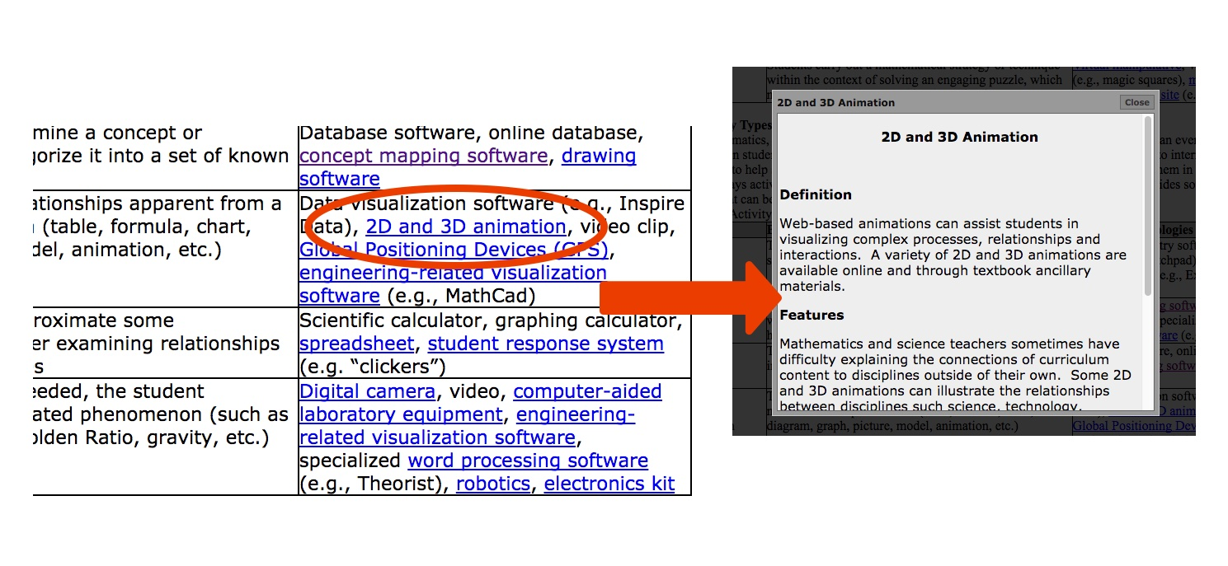  - Show image of 3rd & 4th columns with techs and LATs aligned  -Pause image
4 | Once you have some technological options recorded, it’s time to make selections. Consider the *relative advantage and *fit of each tool in your plan. To what extent does using a particular tool add more value to a learning experience for students than using a different tool? Also, which tools’ characteristics “fit” best what you want your students to do during the lesson or project that you’re planning?  *Your colleagues may be helpful in talking through the challenges and opportunities of different technological options. | - Image of art tools and lines that they’re painting  - Superimpose “relative advantage” and “fit” onto the image, added as we say the two questions.  - Image of group of colleagues talking
5 | *Let’s look at an example. If you chose the Create option for module 4, you’ll recognize this.  *In a social studies project about the key features of the 13 American colonies, the students first view teacher-selected images of life in the 13 colonies. They then read maps and charts along with text excerpts that the teacher selected. At each of these points, students are prompted to take notes. Finally, they consider the evidence they have selected to identify the purposes and key features of each of the 13 colonies. There were a number of technology possibilities to consider for each of these LATs.  *In the View Images activity, presentation software was used to show the students several high-quality images of historical drawings and paintings. This was intended to challenge some of their previously held assumptions.  *During the Read Maps activity, students did access digital resources. This was because the teacher realized the relative advantage of using curated historical Web sites. These sites offered the most illustrative and understandable maps for the lesson.  *The students read text as they researched the purposes and key features of the colonies. While texts were available digitally, for efficiency, the students used their social studies textbooks, supplemented with photocopied paper documents.  *During the lesson, students took notes in their paper notebooks, rather than with digital tools. In this example, the students used an analog tool instead because not all of them had easy access to a laptop, tablet or other digital device.  *In the Consider Evidence activity, the students were challenged to find primary source documents that represent multiple perspectives and viewpoints. A digital archive can help make this process of locating documents more authentic, but still efficient enough for the students to use as part of their learning in the classroom. | - Image of Colonial American flag  - Chart of LATs and corresponding technologies for this project  - Use animations from previous slides. Chart that changes on the left, with images of students doing what is described on the right.  - Need: presentation image  - Need: historical map image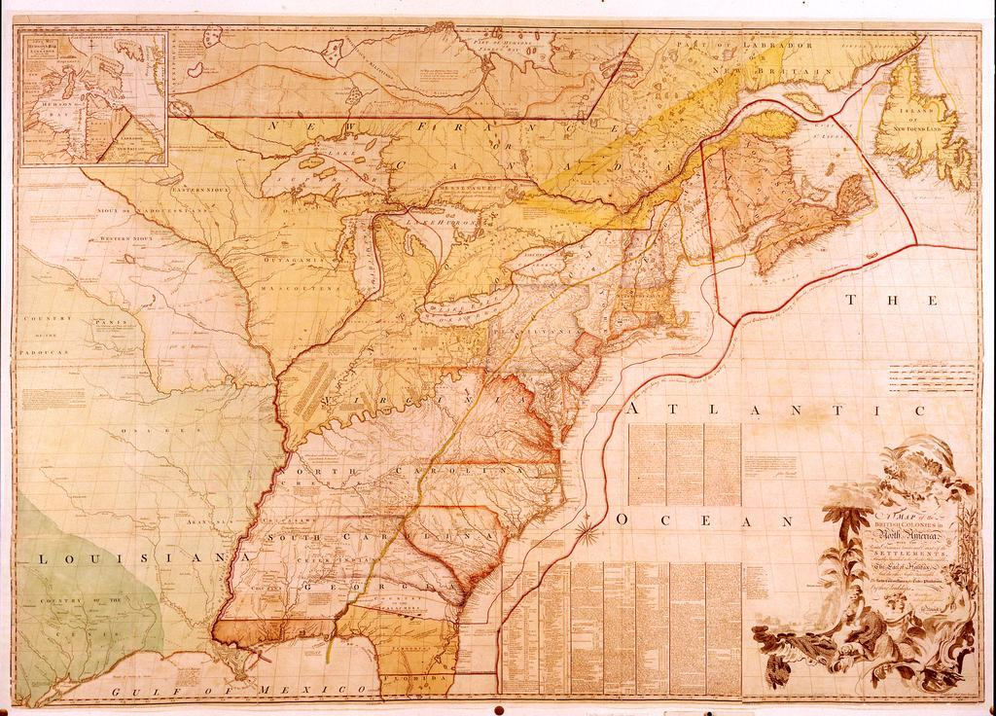  - Need: read text images  Image of taking notes by hand  - Need: primary source documents (e.g., National Archives)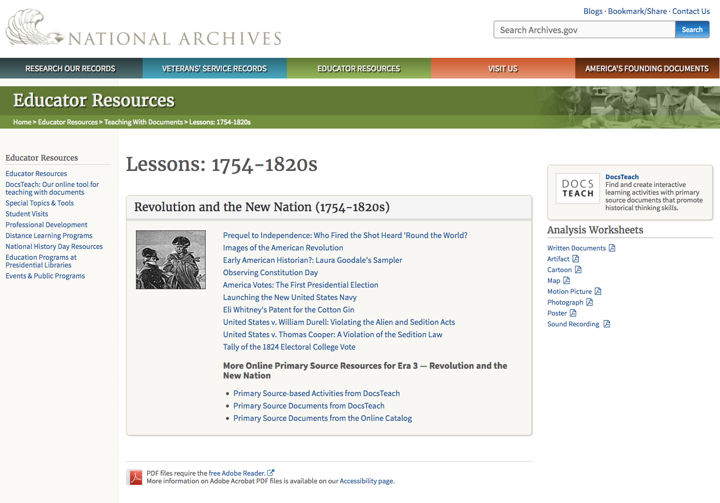
6 | *As this example demonstrates, choices of analog and/or digital tools are dependent on many factors. As you consider different technology possibilities, you can use a simple self-test to help you to decide which types of tools and resources to use in your plan. We call it the “Is It Worth It?” test.  Ask yourself three questions about each tool that you are considering:  - *Will this particular use of a tool or resource help students to do something that is difficult or impossible to do without it?  - *Will this tool or resource help students to do something in a better way?  - *Is the use of this tool or resource feasible, given contextual conditions?  If your answers to all of these questions are “no,” then the technology choices should be reconsidered. If one or two of the answers is “no,” then reconsideration may be necessary. | Image of “is it worth it?” question  Add:  Necessary?  Better?  Practical?  (Put these with the longer questions at the bottom of the second page of the Refresh and Create Guides.)
7 | *Using what you’ve realized using the Is It Worth It? test, please finalize your selections of the specific tools and resources that you plan to incorporate in your plan. *Please pause the video while you note these selections in your Guide. | - Show moving image of deleting or changing some tech possibilities, with a list remaining.
8 | *In this course, you have learned:  - why technocentric approaches to using technology in your teaching don’t work.  - how to plan for students’ learning using curriculum-based learning activity types (LATs).  - to refresh an existing lesson or project, or create a new one, using the LATs approach.  - how to purposefully select educational technologies to support students’ learning with the refreshed or new plan.  *We hope that completing these modules has helped you to know how to integrate technologies effectively into curriculum-based lessons and projects.  *Now please take a moment to reflect on what you will take away from this short course. What are the most important ideas that you will incorporate in your practice? If we had to choose, we would emphasize *fit, *balance, and *choosing technologies last.  *Remember, as we said in module 1: “Good technology integration ISN’T really about technology.” *In the end, it’s all about your students’ learning. | - Title of short course at top.  Add these images on separate slides, with title remaining at top of screen:  - Image of guy with hammer  - Image of gears brain  - Image of smiling chef  - Image of “is it worth it?”  Clear screen except for title.  Add three images from SITE 2017 slides, labeled, one at a time.  - Wipe screen except for the title. Add image of learners of all ages

