Module 6: Select and Sequence Learning Activities
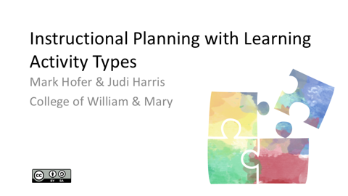  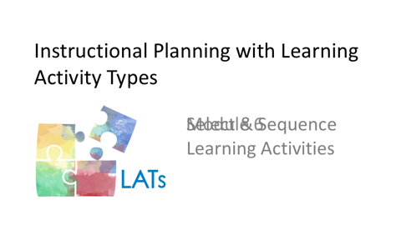  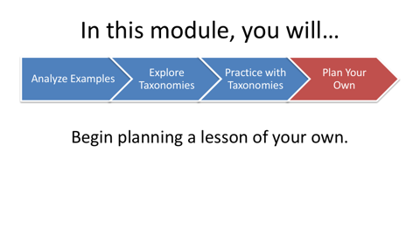 | Now that you have used one or more taxonomies to help you to think through and modify other teachers' lesson plans, it's time to *begin planning your own technology-enhanced learning experience.
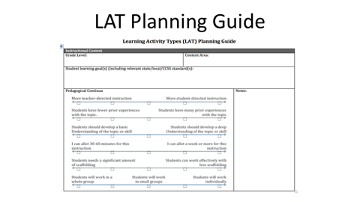 | Before you read further, please download the LAT Planning Guide document that is linked within the LAT Short Course Resources document.  The Planning Guide is designed to be a thinking tool, rather than a lesson planning template. The LAT approach and this Planning Guide are designed to be used with any type of lesson plan. So, as you engage in the planning process, we encourage you to use whatever lesson plan format either you prefer and/or your instructor recommends.
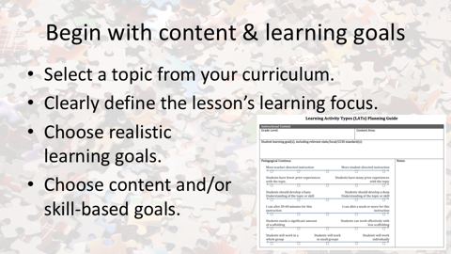 | Since what you are learning here is a curriculum-based planning approach, we encourage you to begin planning by considering the content focus and learning goals for a lesson. You will build this new lesson during the remainder of your work with this short course. Ideally, you should select a topic for your lesson that you will be teaching sometime during the current school year.  Defining the lesson’s learning focus clearly will make it easier to be strategic about selecting and sequencing LATs for the lesson. Please take some time now to *choose realistic learning goals for the lesson. The learning goals may be content and/or skill-based. You can begin to select learning goals with your school’s curriculum scope and sequence, your state’s required curriculum, or with guidance from your mentors.
 | Recall that in the previous module, you learned that LATs are building blocks of lessons that can be combined and sequenced in different ways. These different combinations and sequences result in different learning experiences for students. While considering all possible LATs and technologies for a particular lesson plan can be exciting, it can also be daunting – particularly for novice teachers. How, then, can you determine which LATs "fit" best in each curriculum-based lesson, project, or unit?
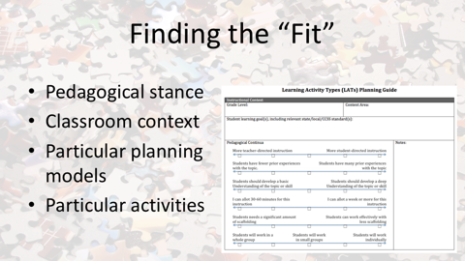 | There are, of course, multiple learning activities that can “fit” a particular instructional plan.  Finding “the best fit” involves considering several dimensions of that plan. *One key determinant is pedagogical stance. For example, if you believe strongly that an inquiry orientation to teaching is the optimal approach, this may guide you to a specific set of possible learning activity types. However, if you are more eclectic in your approach to teaching, there will be more LATs from which to choose for each lesson that you plan.  Another key determinant is the classroom context in which you are working. Teachers consider the students, the classroom, the school, and the community when planning. It is important to consider as many contextual aspects in your planning as possible.  Consider also the particular planning models and learning activities introduced in your teaching methods courses. How can these parameters help you to choose the optimal selection of learning activity types for the lesson that you are planning?
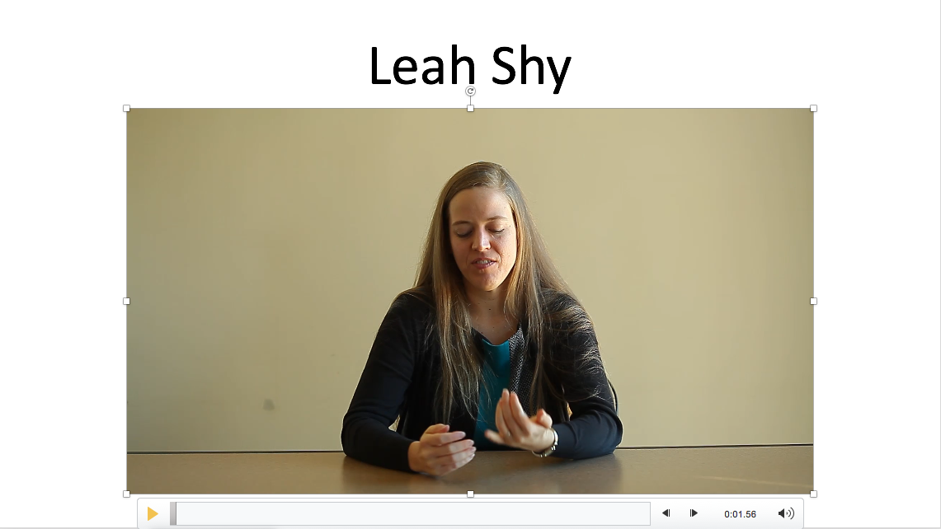 | Experienced teachers consider a host of contextual factors as they plan learning experiences for their students. In this video, Leah discusses how she considers context in her planning.  “You have to consider your students first of all, what your students bring to the classroom because that’s why you’re there, so you have to consider their level in terms of understanding the content, their cognitive level, where they’re at academically, just on that kind of level. That’s probably the first and most important thing.  “Part of that would be if you have students who have identified learning needs or behavioral needs. You have to take those into account. If you have students who have specific language needs, you have to take those into account.  “If you have students from a diverse cultural background that might be a minority background, then you need to take that into account.  “Time is a really big factor that you have to consider. I felt like when I was teaching in independent schools I had more freedom and flexibility that if I wanted a lesson to run long or if I wanted to not do math today and do more math the next day in order to accommodate for something I could do that.  “In the States, that’s not always possible with the high stakes that are attached to the testing now, if you’re in a grade level where science is being tested, you’re going to be expected to do more science and social studies might not have as much attention. Or vice versa.  “Districts will often have set amount of times that you have to spend, two hours in language arts or something like that, that you have to take into account.  “So, the time constraints on your school day is what’s put on you—that’s a big consideration.  “You have to know your administration. If your administration, your principal, has certain expectations, that’s important. Sometimes an administration will have a certain perspective about what’s appropriate philosophically and sometimes that can be in terms of your management and what the class looks like, and so that might change what you do or what you don’t do.  “Being aware of that is really important and how parents might fit into that as well. If you’re at a school where parents are expected to do a lot and the administration encourages volunteers that’s different than if you’re at a school where parents are busy working two or three jobs and aren’t able to come in or aren’t able to support their students at home doing outside work then that changes what you might do.  “Having started at a school that was a public school with not a lot of funding, I found that I had to really be thinking about what’s available to use, because it didn’t matter how wonderful my lesson plan was and what a terrific activity I had found if I, if it required resources that I didn’t have access to, I couldn’t do it. So I had to be creative, I had to be resourceful, I had to be thinking about what was available as a, sort of a baseline to start.”
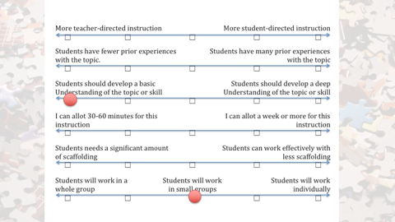 | This graphic illustrates some of the context-related decisions that you will make as you plan your lesson. This chart is included in the LAT Planning Guide document.  As you review the continua on the chart, indicate a point on each to represent what you know about the contextual conditions for your lesson. For example, if your students have had little prior experience with a new topic, you should note this with a dot on the continuum closer to the “surface” level than to the “deep” knowledge level. Similarly, if you think the topic is best approached through small-group work rather than as a whole-class activity, you can note this on the appropriate continuum, also.  Doing this will make choosing learning activities and technologies easier. You may have limited information about the context for which you are planning at this point, however, so you may not be able to use all of the continua. *You could consult with your mentors about these decisions. Otherwise, please use your best educated guess to place a dot on each of the continua. Please complete this chart in the LAT Planning Guide before proceeding to the next segment. In that module, you will begin to select and sequence the learning activity types for your plan.

