Conclusion
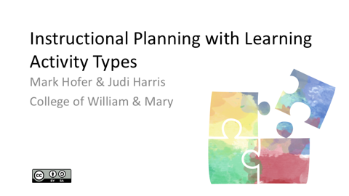 | We hope that your experience with this online short course has helped you to see technology integration in pragmatic, curriculum-based and student learning-focused ways. We also hope that you have a new set of thinking tools to help you to consider and plan for technology use in your teaching more strategically.  For more information, articles, and presentations related to the Learning Activity Types approach, please visit the LAT Web site that is located at the address displayed here.
We would appreciate receiving any feedback about this short course that you would like to share., We will continue to develop and refine this open educational resource while considering feedback that students and instructors provide.

To share your experience with us, please complete the brief survey that is located at the address displayed on the screen. Thank you in advance for your contributions!

