Module 1: Introduction

Slide# | Script | Visual(s)
1 | *Does your principal want you to use technology more often in your teaching?  Have you seen a new tool that you know that your students would enjoy using, but you’re not sure how it would fit within your curriculum?  Are there more tools in your school than you know what to do with?  *Believe it or not, good technology integration ISN’T about technology. | - Series of quickly-appearing images of classroom technologies -- additive (increase speed as the series continues).  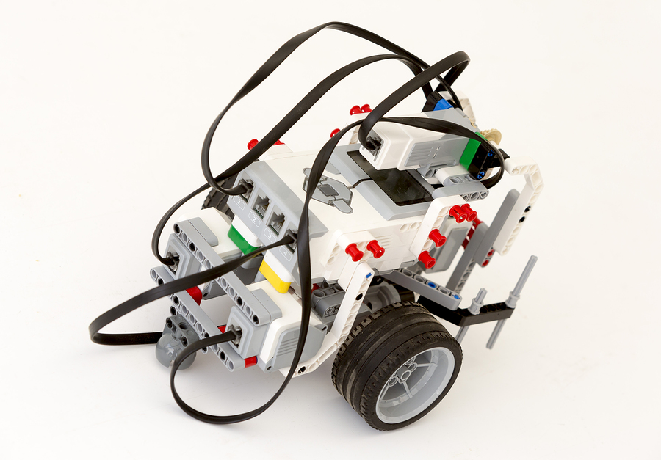  - Abrupt stop with final quote (on left) popping out in the middle
 | Hi! * I’m Mark Hofer (*and I’m Judi Harris). We are faculty members in the *School of Education at the College of William & Mary in eastern Virginia in the United States.  In this short course, we will share an approach to curriculum-based technology integration that we have developed, researched, and tested. *What’s distinctive about this approach is that it focuses on planning for students’ learning rather than planning for technology integration. Here’s why. | - Images of Mark & Judi & school logo.  - Image: TeacherPlanning-LookingOverShoulder
2 | ** Twenty-nine different software packages were recognized nationally several years ago for *their potential to quote transform student learning end-quote. In a recent follow-up study, *most had no impact on student learning outcomes. *Only those titles that required redesigning courses or school-wide buy-in showed moderate positive effects on student learning. | Means, et al. (2016)  - 29 software titles  - “transform student learning”  - Most: No impact  - For impact: Large-scale change
3 | * By contrast, in a comprehensive review of research about *one-to-one computer initiatives in schools, multiple studies documented *increased student achievement in science, writing, math, and English. *They also reported teachers using more student-centered, individualized, and project-based approaches. *Many of the studies also noted increased student engagement in learning. | Zheng, et al. (2016)  - 1:1 computer initiatives  - Increased learning in science, writing, math, and English  - More student-centered, individualized, project-based  - Better student engagement
4 | *What about computer use with young children? The results are mixed.* Story comprehension and vocabulary have been positively affected by *the use of electronic books with *animated illustrations and sound. *However, interactive elements like hotspots and games did not help to improve literacy. *Economically disadvantaged children were more sensitive to both positive and negative effects. | Tackas, et al. (2015)  - Young children: Comprehension and vocabulary  - Electronic books and stories  - Helped: Animations; sound  - Didn’t help: Interactive elements  - More for children at risk
5 | *In another mixed-results review of more than 350 studies about *using technologies to learn foreign languages, the authors concluded that *quote evidence of efficacy is limited end-quote. *However, computer-supported pronunciation training and *using chatting tools for communication in target languages were associated strongly with learning gains. | Golonka, et al. (2012)  - Technology in foreign language learning  - “Evidence of efficacy is limited”  - Helped: Computer-supported pronunciation  - Helped: Online chatting in target languages
7 | * Why are there such large differences among these syntheses of research about educational technology use? *A meta-analysis of research about computer use with elementary students attributed large differences in reported effect sizes to *differences in content being learned, *type of technology use, *length of technology use, and *variable learning environments. | Chauhan (2017)  - Computer use with elementary-level students  - Curriculum differences  - Hardware and software differences  - Length of use  - Learning environment differences
6 | *As you can see, while some research findings about educational technology’s impact on learning have been promising, others have reported little or mixed impact. | Image of a teacher/professional who is frowning? Puzzled?
7 | *The learning gains reported in these research syntheses have something important in common, however. *What is it? | - Display the five abbreviated citations from above, distributed on the screen, at different angles  -Superimpose a question mark in the middle (image: question mark made of question marks)
8 | In the *studies cited here that documented student learning gains, the approaches used emphasized *CURRICULUM-based *teaching and learning STRATEGIES. Those strategies made productive *USE of educational technologies, *but didn’t focus on them. | - Begin with question mark & study citations still on-screen  - Remove question mark only.  - Delete study citations.  - Display filled-in circle with “Curriculum” inside it. Use same color as Content circle in the module that explains TPACK.  - Display filled-in circle (different color) with “Teaching/Learning Strategies” inside it next to the Curriculum circle. Use same color as Pedagogy circle in the module that explains TPACK.  - Display filled-in circle (different color) with “Technologies” inside it at the top, centered. Use same color as Technology circle in the module that explains TPACK.  - Move the three circles together, foreshadowing TPACK. Intersections should be the same colors as TPACK diagram in later module.  [Brief pause.]
 | *Sadly, for about 40 years, even though we’ve been trying HARD to integrate technologies into teaching and learning, although we’ve made some progress, many would argue that the gains are not proportional to the amount of *time, *energy, and *money that we’ve spent. | Clean screen.  Images, appearing one at a time: flat-line graph, then not-equal-to sign, then clock, light bulb, dollar sign
 | *We strongly suspect that this is due to the technology-focused nature of most educational technology efforts, including professional development for teachers.  MIT’s Seymour Papert coined a term for this more than 30 years ago: technocentrism. | “Gadget Guy” – like image  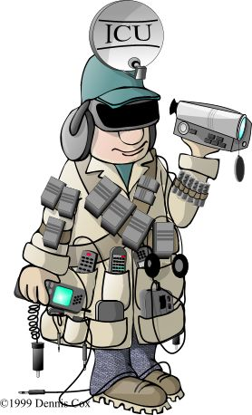  - Video clip of Papert explaining technocentrism
 | *You’ve experienced technocentric thinking, whether you know it or not. How many blog posts, tweets, conference sessions or professional development workshops have you seen that focus on technologies, rather than teaching? | - Animated session titles that are clearly technocentric, e.g., “50 Ways to Use Twitter” going in different directions and piling on top of each other
 | *So, what’s a teacher to do? If you want to learn to use technologies effectively in your teaching, how can you do this without focusing TOO much on the technologies? How can you learn to integrate technologies in CURRICULUM- and STUDENT-centered ways? | Clean screen.  Multiple images of students using digital tools in different ways. (Different ages of students.)
 | *What’s needed here is an approach to technology integration that emphasizes CURRICULUM and PEDAGOGY over technology. That’s what this course is all about. | Clean screen.  Multiple images of curriculum content (from past presentation slides)
 | *Of course it’s important to learn what technologies are available, and how to use them in your classroom, but it’s much simpler and quicker to learn to USE technologies than to learn *HOW to use them with STUDENTS. So, this course WILL include technology, but will emphasize curriculum and learning. | Split screen: on left, image or muted video of software tutorial; on right, image or muted video of teacher working with students with technologies  - https://www.youtube.com/  watch?v=24KEMgwoHZA
 | *Spoiler Alert! We argue that when planning instruction, you should choose the technologies LAST. | Graphic of “spoiler alert.”  Replace with: “Choose the technologies LAST.”  Brief pause. Video of someone saying “WHAT?!” – changed to text because of fuzzy image
 | *In this course, we will share a set of free materials that you can use to help you to plan lessons, units and projects that will integrate technologies without being technocentric.  *First, we will introduce the materials and how to use them in your planning.  *Then, you will have an opportunity to practice using them with some of your favorite lessons or projects.  *Then, you can either create a new lesson or project OR refresh one of your existing plans to incorporate educational technologies.  *And finally – last but not least – you’ll choose the technologies to use in these plans.  Along the way and after the course ends, you’ll have unlimited access to all of the materials to download, customize, and share, plus many examples of their use in different classrooms. | Animate in a list of the modules (number and titles) with a graphic symbol for each that’s also used in the module, displayed with the title (e.g. “Module 1: Introduction”) and the graphic symbol on every screen in the same position.  Graphics:  Introduction - Compass  The LAT Approach – Jigsaw puzzle pieces partially connected  Exploring Taxonomies – Gears Brain  Planning – Flowchart on glass  Tech Selections – Bouquet of cables with connectors
 | *The course is organized into sequential modules. We suggest that you complete them in order. Each module will begin with a brief list of its contents. If you already have extensive experience with some of the content of a module, you may want to skip ahead to the parts that are new to you, or even skip the module all together. You can always go back to review parts of the modules as necessary.  *Are you someone who likes to plan ahead? Click on the folder cleverly named “Learning First Documents” to download documents that you will be using in this short course. | Image: Compass  Video: (muted) scrolling through one of the later modules, skipping to and back from segments within the module.  Image of binder with colored tabs
 | *Ready? Let’s go.  In the next module, you will learn about connecting content, *pedagogy, and *technology in planning. You might be tempted to skip ahead, but we encourage you to give the next module a look. It contains important ideas that you will use throughout the course.  See you in Module 2. | Animated image:  Content, pedagogy, and technology circles moving together, then context dotted circle at end. Then display “TPACK.”
Underneath the video window on webpage:
Include links (APA citations) to studies in two groups (limited and positive impact); download any that are public domain

