Module 1: Introduction
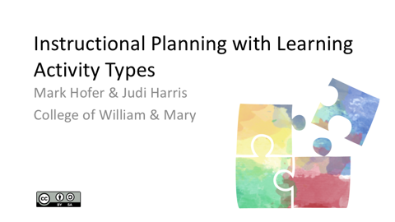
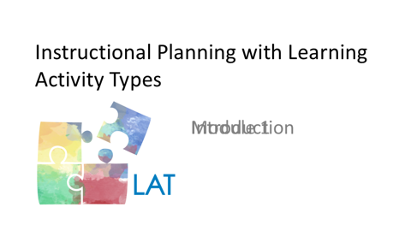

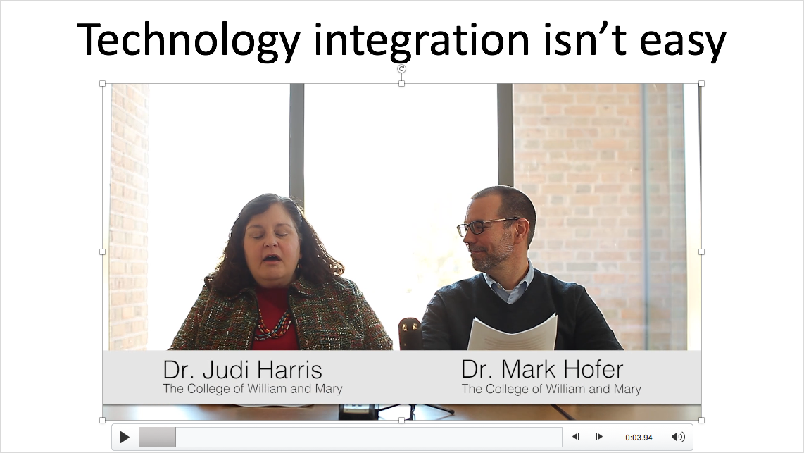 | The deliberate and thoughtful integration of technology in teaching and learning can be challenging – particularly for novice teachers. We have to simultaneously consider the curriculum focus for the learning experience, how to structure the learning experience in terms of learning activities, and how particular technology tools and resources can support, enhance or extend the experience.  My name is Judi Harris and I’m Mark Hofer. We’re faculty members in the School of Education at the College of William & Mary. We’ve worked together to develop the approach and content for this lesson planning online short course.
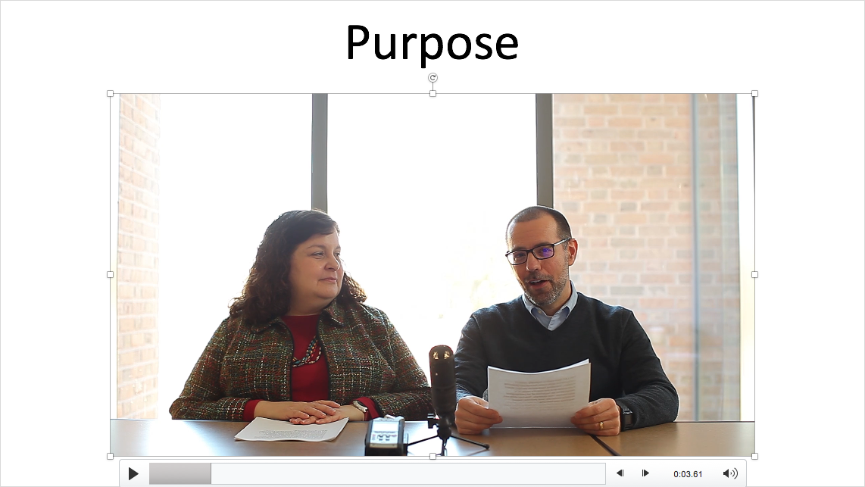 | The goal of the following modules is to help guide you through the process of designing an effective learning experience for your students that leverages the unique possibilities of educational technologies. It introduces the Learning Activity Types (LAT) approach, which we developed to help teachers ground their use of technologies in curriculum-based teaching and learning.
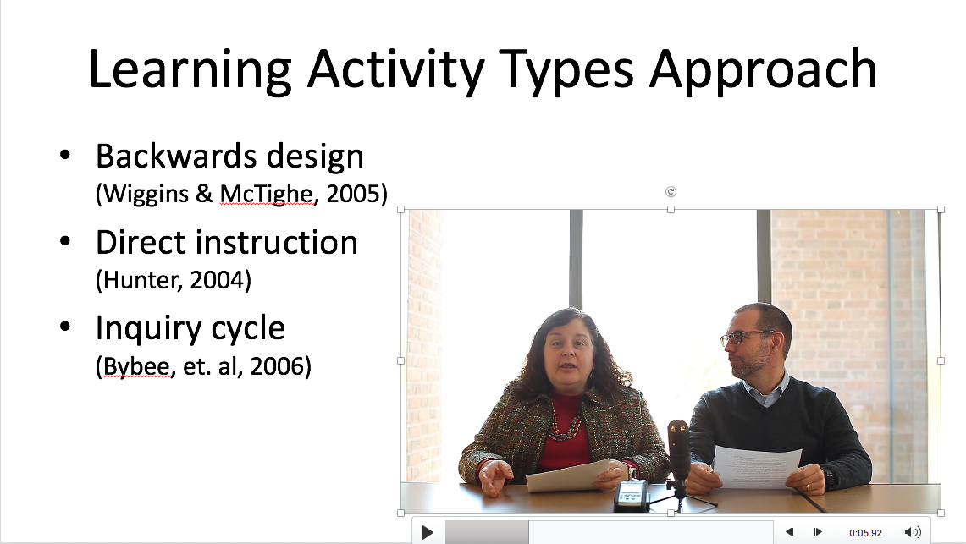 | The LAT approach is typically used in conjunction with more formalized planning models, including *backwards design, *direct instruction and the *inquiry cycle. It is designed to be inclusive of all pedagogical approaches (e.g., teacher-directed, student-centered, problem-based).
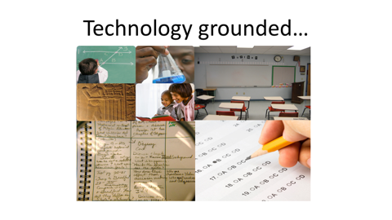 | Its operational focus ensures that the use of technology is "grounded" in students' curriculum-based learning needs, real classroom contexts, and the particular learning activities and assessments employed.
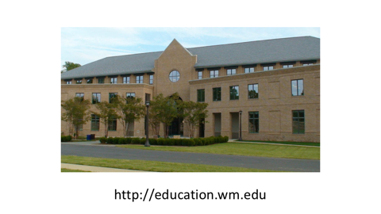  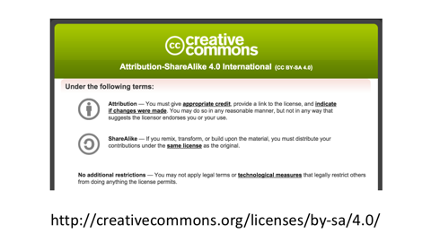  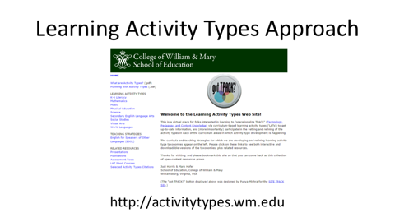 | We created this approach and course originally to be used in the teacher preparation program at the College of William & Mary.  We’ve now offered the course content as Open Educational Resources, or OER’s, for use and modification by faculty from other education programs.  Materials that support (and are essential to) the LAT approach and this short course are freely available online at: http://activitytypes.wm.edu/shortcourse.
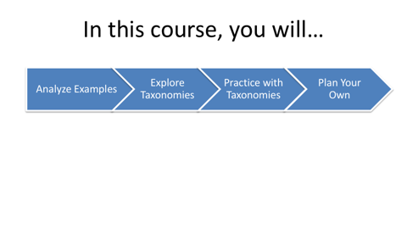 | During this short course, you will first select and analyze examples of existing lessons that integrate digital tools and resources. Then you will explore taxonomies of the types of learning activities that integrate digital tools and resources in different curriculum areas. You will then practice using the taxonomies by modifying existing lessons, then will continue to use one or more taxonomies of your choice to plan a lesson of your own.
As you begin this experience, you may want to take a moment to think about several examples of technology use for learning in school. Which were most effective? Which were least effective? What characteristics made them so, in your opinion?

Please consider sharing these observed characteristics of effective and ineffective educational uses of technologies by adding comments via the discussion area your instructor has provided. Please also feel welcomed to respond to others’ comments by responding in the discussion forum.

