Module 2: The Learning Activities Types (LAT) Approach

Slide# | Script | Visual(s)
1 | *Ms. Jones, a middle-school social studies teacher, came back from her state educational technology conference very excited about a session on game-based learning. The presenter mentioned some research that found that *middle school students’ problem-solving skills improved when they played simulation games in their history classes. *Always focused on her students’ learning, Ms. Jones was inspired to try this with her class. | - Image of conference presentation with (second) text about particular problem-solving skills that improved.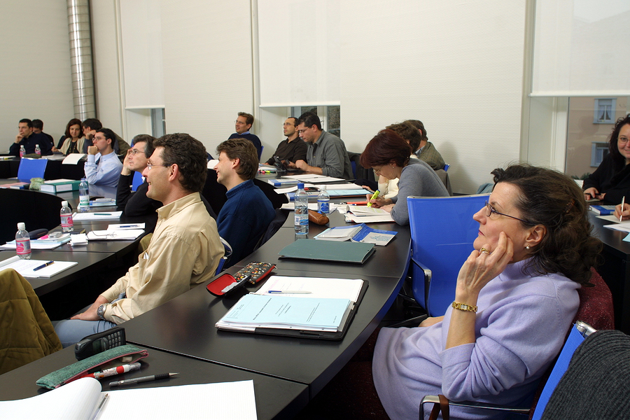  - “Ideas loading” image superimposed
2 | As soon as she returned home, Ms. Jones searched on the Web for *history simulation games for her students to use. She found one that seemed like it would be engaging for them and the content was related to the social studies curriculum. She planned to introduce the game during the next week. | - Screen grab of a vaguely historical, but clearly game-based simulation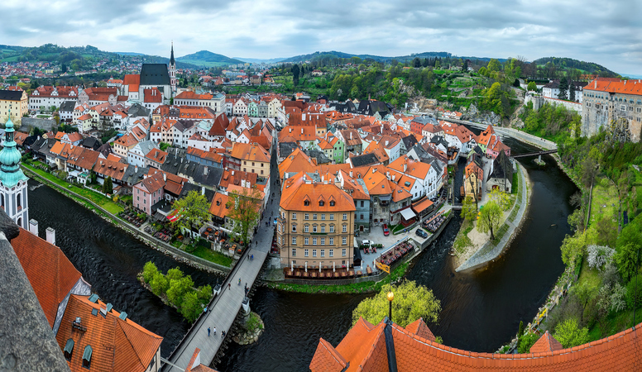
3 | *Her students were as excited about playing the game as she was. Unfortunately, as they used precious class time to play the game, Ms. Jones realized that not only were they struggling with the vocabulary; the students were focusing more on playing the game than on the historical content that Ms. Jones had hoped that they would learn. *While they clearly enjoyed the experience (and asked to play the game again in class), Ms. Jones was unsure about whether the history that they learned and the problem-solving that they experienced were worth it. | - Image of students working in groups with computers who are excited  - Image of a professional woman who is questioning or confused (superimposed upon the excited kids image)
4 | *In reflecting back on this experience integrating this particular technology into her students’ learning, Ms. Jones realized that she had gotten so excited about the game-based, engaging experience that the simulation provided that she hadn’t fully considered how well playing the game would connect with her curriculum. *She also questioned whether the way she encouraged the students to play the game truly helped to improve their problem-solving. | - Another image of the same teacher just used in slide 3, realizing something  - Then show “Was it worth it?” added to the slide.
5 | *As this scenario illustrates, even with the best intentions, it can be challenging to integrate use of educational technologies in ways that are well-aligned with both **curriculum goals and **teaching approaches. It’s far too easy to become technocentric when we think that our students will enjoy using a particular technology.  **In this module, then, we will share a way of planning instruction that helps to ensure that technology, content, and pedagogy are balanced and fit together well. | - Image of old-school level with a bubble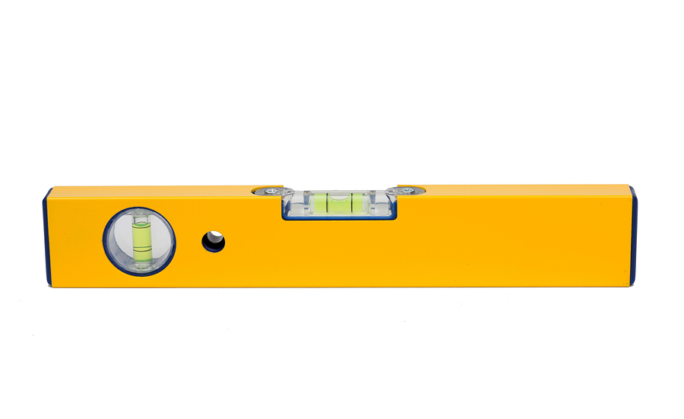  - Add text underneath: technology (left), curriculum goals (right), teaching approaches (center)  - Level with techs appears first, then curric goals teaching approaches as we say them  - As we add the text on the ends, make the level lean in that direction, then end with it level (at “ensure”)
6 | *If the goal is balance among curriculum, teaching approaches, and technology use, how is this accomplished?  Since 2005, educational technology researchers have been exploring this question. We have learned that there is a complex but essential type of knowledge that teachers need to be able to integrate educational technologies successfully into curriculum-based teaching. This type of knowledge is known as *“technology, pedagogy and content knowledge,” or TPACK. | - Repeat briefly the level with 3 labels image  - Level image disappears. Image of brain made of gears (animated, if possible) with TPACK imposed on top of it as a second step.
7 | While the knowledge needed is complex, the concept is simple, especially for experienced teachers.  *As an experienced teacher, you already know how important it is to know your curriculum.  *You also know how helpful it can be to have a broad range of different teaching strategies available to draw upon so that you can reach as many students as possible.  *Experienced teachers draw upon these two types of knowledge simultaneously when they plan effective instruction.  The knowledge needed to align curriculum goals with appropriate teaching strategies becomes more complicated, however, when we attempt to integrate use of *digital tools and resources.  *And all of this happens within the complex contexts of the classroom, such as language differences, types of technology access, and school culture.  *When a teacher uses all of these types of knowledge together, we say that the teacher is using TPACK.  *How can teachers develop their TPACK? | - Still image of gears-brain with TPACK superimposed upon it. Transition type: explode (coming toward the viewer)  - As each element is discussed, make the circles appear. Tech should be underneath content and pedagogy (aligned). Circles appear separately and with colors that will mix in overlapping parts.  - Illustrate PCK with circles overlapping when “two types of knowledge” is said.  - Tech circle appears here.  - Move tech circle when “…attempt to integrate…” is said  - Contexts dotted circle appears here.  - Animate in a largish ‘TPACK’ label underneath the circles.
8 | *One way to do this is to introduce teachers to different technologies that can be used in their teaching. Unfortunately, this approach can be technocentric, putting too much emphasis upon finding ways to incorporate use of technologies in instruction.  We have discovered another, more organic, way to help teachers to develop their TPACK: *through instructional planning. | - First image: just add a question mark to TPACK.  - Image of little guy with big hammer surrounded by nails.  - Cube transition, then planning book image with “Instructional Planning” underneath it.
9 | *Here’s what we know about how experienced teachers plan instruction.  Researchers have found that teachers’ planning is focused upon curriculum-based *learning goals and objectives, and is sensitive to *students’ learning needs and preferences. Also (and importantly), experienced teachers’ plans are structured with a sequence of learning activities for their students.  So, how can we use what we know about how teachers plan instruction to help build TPACK? | - Image of professional working on something at her desk  - Bullets:  - Learning goals  - Students’ needs/preferences  - Learning activities
10 | *One way is to consider all of the different learning activities that are available within particular curriculum areas, and appropriate technologies that can enhance each.  *What if any teacher could use a comprehensive list of types of learning activities and corresponding technologies to help plan effective learning experiences for their students?  *There are taxonomies of these learning activity types – or LATs – freely available online that teachers around the world use in their planning.  Beginning in the next module, you will have opportunities to explore these taxonomies and later learn to use them in your teaching practice. During this process, you will build your TPACK and identify effective ways to integrate technologies into your teaching and your students’ learning. | - Same slide as above  Circle “learning activities”  - Teacher image disappears with a cube transition.  - Keep circled learning activities text.  - Add image of a long list with nonspecific text on it  - Screen shot of LATs website