Lesson 8: Technology Selections
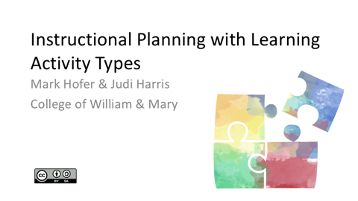  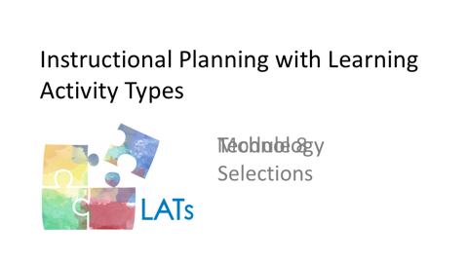  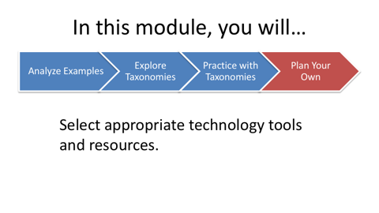 | After you have developed a promising sequence of learning activities for the lesson that you are designing, it’s time to consider technology possibilities. Some recommendations for appropriate digital tools and resources for each LAT appear in the third columns of the taxonomies.  Please note that you may not (in fact, probably should not) select a technology to support each LAT within the lesson that you are designing. There are many different factors to consider as you determine when and how to integrate technologies in your teaching. Most important of these are your students’ learning needs and preferences.
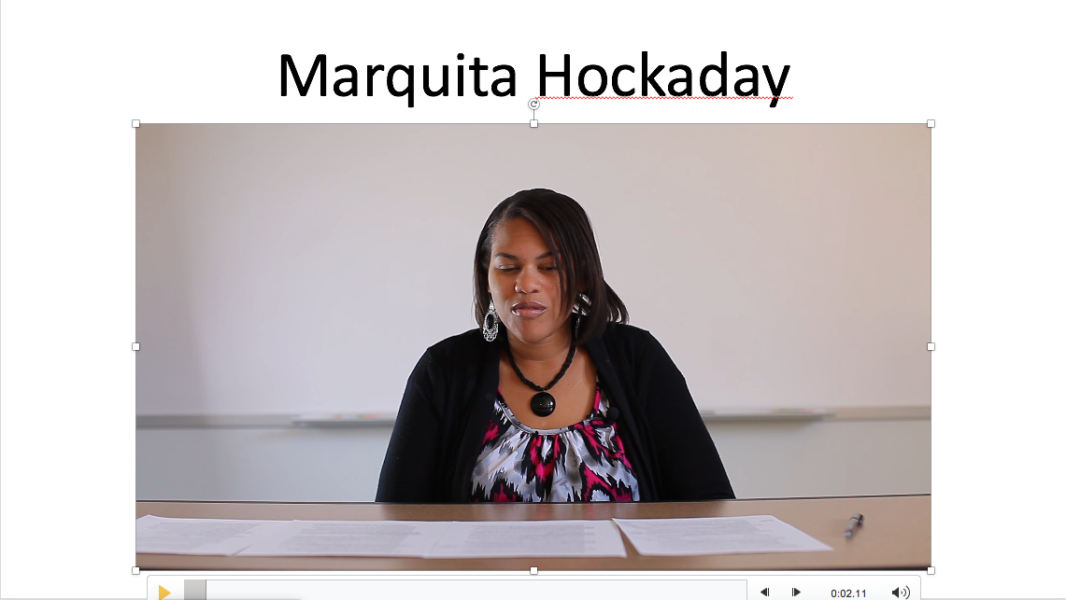 | In this video, Marquita describes how her students used technologies effectively as part of a World History review project.  “I did have a World History project, too, where the students had to create games and they had to do it for reviewing of SOLs. And with that one, there were several different types of technologies because some of them did like, Jeopardy-type games, some did board games, some did simulations where they actual create. Like, they went all out where there were—I don’t even know how they created these technologies! There were figures and so it was like, Game of Throne type games. I couldn’t even tell you some of the technologies that they used with those, but it was very intense.  “And they did like circulation with that, so it was—I’m trying to remember the phrasing for this—where they’re set up in different groups like round robin and they each had to play each others’ games for reviewing of SOLs. So I knew they were successful in that sense because it was competition where they had to try to win each others’ games. And I even had one group do a Twister type game where they had to get on the floor and actually, yeah—so it was very intense.  “I integrated the technology for World History because my students, while they have to understand the SOL, and these are freshman, so they’re ninth graders and its World History. It’s intense SOLs at that point. It’s not very relevant information to them, it’s not applicable, but when they get to play games and they get to engage with each other and it becomes a competition, they tend to understand and retain the information that way, so I found it to be something that was fun for them, but also something that engaged them and that was interesting.  “I think it was more effective because they actually got to do something with the material. So it wasn’t just them, it wasn’t rote memorization, it wasn’t just ‘Let me sit down and take these notes and regurgitate information to you.’ It was the doing, it was action. And so I think that was more effective for them.  “I think technology is very effective in learning because when students are able to actually make things and create things it gives them more ownership and just allows them to feel like they are in charge of their learning and whenever students are in charge of their learning, they’re more apt to do better and actually put their all into something. And I think that’s true, too, when you tell them that things are going to be published and put out to the world. They’re more actively engaged in their learning.”
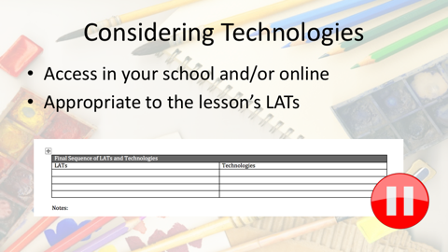 | When deciding which technologies to incorporate in your lesson, first consider which are available and easily accessible in your school and/or online. Then consider which of the available technologies are most appropriate for use within the particular learning activities you have selected and sequenced. Please pause here and list these appropriate and available technologies in your LAT Planning Guide document. Please note that you probably won’t include all of these possibilities in your final lesson design.
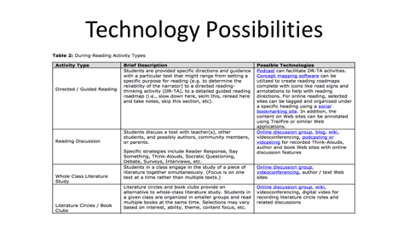 | Please note that the technologies suggested for each learning activity type in the taxonomies are not meant to be exhaustive lists. Instead, we hope that they will provide you with ideas for tools and resources to explore within your lesson.  If there are tools listed in the taxonomies that are not familiar to you, please consider clicking on the links provided to learn more about them. While you are exploring the tools, you may realize that one or more are not the best fit for the lesson that you are designing.
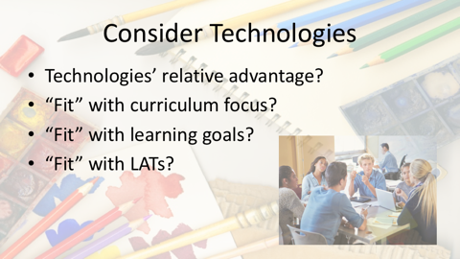 | Once you have some technological options selected, consider the relative advantage of each tool to assist you in teaching the lesson. Which tools’ characteristics “fit” best what you want your students to do during the lesson that you’re planning?  Think about how well each technology that you’re considering "fits" with the curriculum focus, learning goals, and learning activities that comprise your emerging lesson plan. Your colleagues and mentors can be helpful in talking through the challenges and opportunities of different technological options.
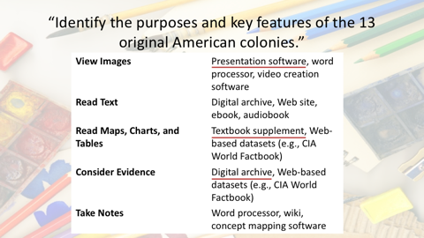 | For example, if we look back at the 13 American colonies lesson from the previous module, we can see that there are a number of technology possibilities for each of the LATs incorporated.  In the View Images activity, presentation software was used to show the class several high-quality images of historical drawings and paintings. This was intended to challenge some of the students’ previously held assumptions.  The students read text as they researched the purposes and key features of the colonies. While texts were available digitally, for efficiency, the students used their social studies textbook, supplemented with photocopied paper documents.  During the Read Maps activity, students did access digital resources. This was because the teacher realized the relative advantage of using curated historical Web sites. These sites offered the most illustrative and understandable maps for the lesson.  In the Consider Evidence activity, the students were challenged to find primary source documents that represent multiple perspectives and viewpoints. A digital archive can help make this process of locating documents more authentic, but still efficient enough for the students to use as part of their learning in the classroom.  During the lesson, students took notes in their paper notebooks, rather than with digital tools. In this example, the students used an analog tool instead because not all of them had easy access to a laptop, tablet or other digital device.
As this example demonstrates, choices of analog and/or digital tools are dependent on many factors. As you consider different technology possibilities, you can use a simple self-test to help you to decide which types of tools and resources to use. We call it the “Is It Worth It?” test.

Ask yourself three questions about each tool that you are considering:
- Will this particular use of a tool or resource help students to do something that is difficult or impossible to do without it?
- Will this tool or resource help students to do something in a better way?
- Is the use of this tool or resource feasible, given contextual conditions?

If your answers to all of these questions are “no,” then the technology choices should be reconsidered. If one or two of the answers is “no,” then reconsideration may be necessary.

In some cases, choosing not to use a technology may be the best pedagogical decision. In this video, Marquita discusses an example of when she chose not to incorporate a particular technology in a lesson, why she made this decision, and what she helped students to do instead.

“So this is World History, so it’s ninth graders. And we were working on William the Conquerer and students had to understand how he actually conquered England at the Battle of Hastings. And so what we were going to do was completely create a comic strip online and I decided against doing that because I felt like they weren’t really going to truly understand how he conquered England from that.

“And so what I did instead was printed out the actual Bayeux Tapestry which is from the Reading Museum in England and it kind of gives you the full story of how he conquered England at the Battle of Hastings. And it’s an old primary source that shows you what happened at the battle. And so I printed it out, I cut it up for all of my students, and I was going to have them put it in order. So, it’s a critical thinking assignment and it’s very hard to do because they have to look at this actual primary source and put it in order from beginning to end to show how he conquered this area.

“But what I had to do, so why this is a half-way, no and yes, is because they did use technology in a sense. They looked at a YouTube video that shows the Battle of Hastings and they could use the Reading Museum’s website and look at the Bayeux Tapestry themselves. So they could use these sources to help them put things in order. But they had to use glue sticks and paper to glue the Bayeux Tapestry back together. So it was kind of a hands-on assignment using technology in a sense.”

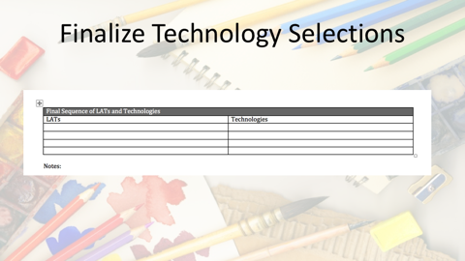 | Using what you’ve learned from Marquita and the Is It Worth It? test, please finalize your selections of the specific tools and resources that you plan to incorporate in your lesson. Please note these selections in your LAT Planning Guide.
Now that all of the parts of your lesson have been assembled and sequenced, it’s time to do one final check. Earlier, you used the Is it worth it? test to determine when (and when not) to use particular technologies in your lesson.

Now we suggest that you perform a similar, but more comprehensive, self-test. This test will help you to ensure productive use of your students’ time and energy and a high quality learning experience. Ask yourself:

- Will this lesson design work, given all of the contextual factors that we discussed earlier?
- Is this lesson design appropriate for your students, given their learning needs, preferences, and developmental readiness?
Is this the best possible combination and sequence of learning activities and technologies to help your students meet the specified learning goals?

If your answer to any of these questions is “no,” then the lesson design needs revision. Talk with your colleagues and mentors for ideas on how to improve it.
We hope that completing these modules has helped you to know how to integrate technologies effectively into curriculum-based lessons.

As fellow teachers, though, we acknowledge that we can learn just as much or more from working with our students. So, as you implement the lesson you have planned, be open to new insights that you can glean from how your students respond to what you have designed.

