Learning Activity Types (LATs) Planning Guide

Instructional Context
Grade Level: | Content Area:
Student learning goal(s), including relevant state/local/CCSS standard(s):

Pedagogical Continua  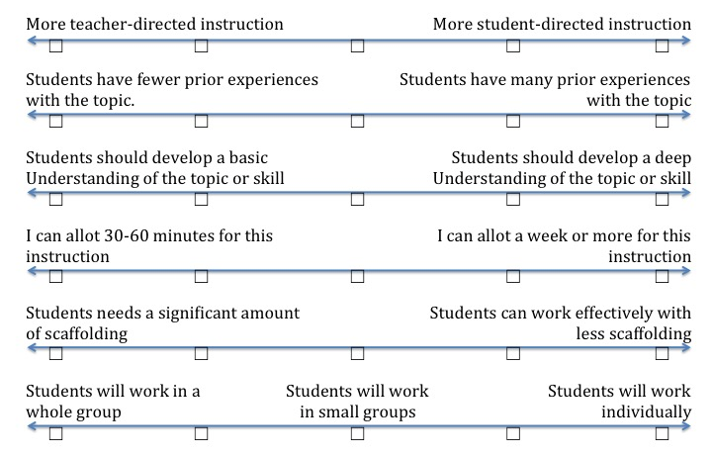 |  | Notes:

Learning Goal Classification and Taxonomy Subcategories
Learning Goal | Content or Process Focus? | Relevant Taxonomy Subcategorie(s)

Notes:

LAT and Technology Selections
Learning Goal | Possible LATs | Selected LAT | Possible Technologies | Selected Technologies

Notes:

Final Sequence of LATs and Technologies
LATs | Technologies

Notes:

