Module 2: Explore and Analyze Existing Lessons
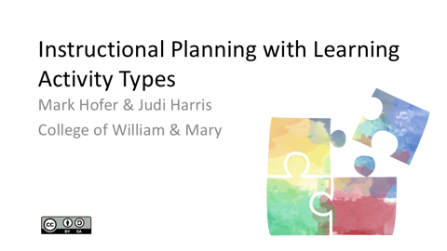  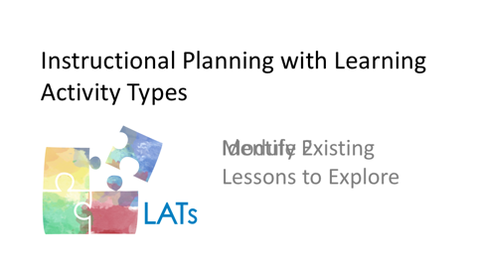 | One way to begin to explore how the integration of technology can enhance students’ learning is by investigating how other teachers have approached this challenge.
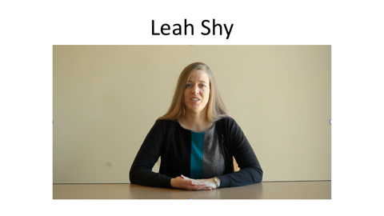 | Beginning in this module, you’ll have the opportunity to hear from a colleague. Leah Shy has recently taught early elementary-level students in all content areas in the United States and Japan. She has been using digital tools and resources in her teaching for several years. Leah will share with you how she navigates this decision-making and planning process. While you and she undoubtedly will approach these tasks somewhat differently, it can be helpful to understand how another teacher draws on her knowledge and experience to plan lessons that make effective use of technologies for her students.
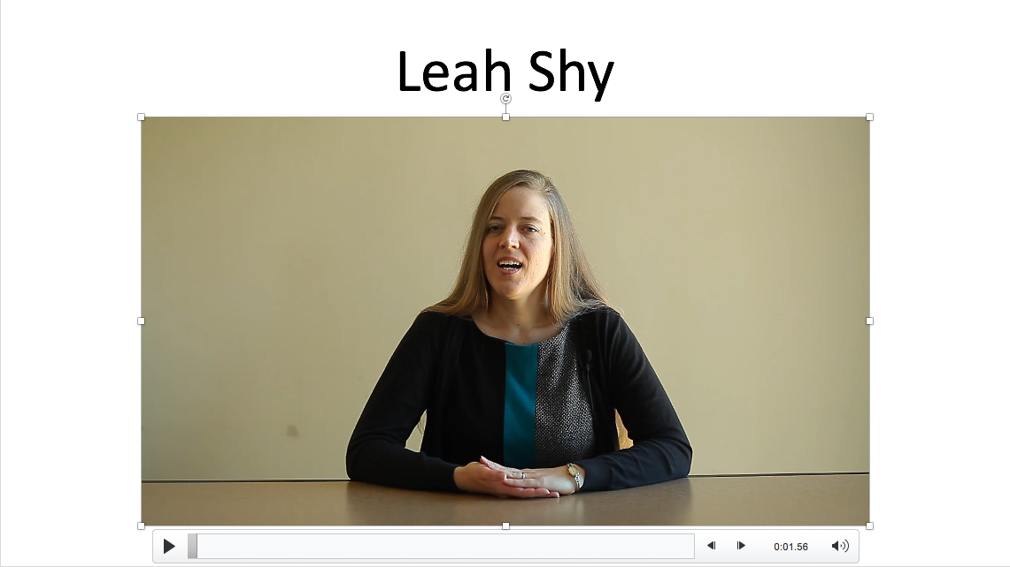 | Here’s how Leah finds lessons to inspire her work with her students, and chooses among the many options available.  I like to get a lot of my ideas either from talking with other colleagues and hearing what they're doing in their classroom or just trying to be creative with the materials that I'm familiar with. I personally don't go to idea books or websites a lot.  I find that one of the things that I really enjoy about teaching is being able to be creative and thinking about my students and what they need in their learning to try to come up with ideas that will best help them. I find that for me, when I go to other resources or idea banks that are all fully developed, I end up adapting things so much for my students that I would be better off just starting on my own.  Children's literature provides a lot of inspiration for me. I love spending time in the school library and just listening to the librarian give recommendations of books and using those as starting off points, not just for language arts activities. Certainly for those, but also for math, social studies, science, really for any of the subjects, I love getting into children's literature. Teaching early elementary, that's such a powerful way, I think, to enter into learning activities and engage the students. And there's so much out there. And I think that's so important for their learning.  I also really like seeing what other teachers are doing. I find that talking to colleagues, being able to work with other teachers at the grade level, even if I'm not able to watch what they're doing, just to see their students' work, to see what's hanging on bulletin boards, to see evidence of what students are learning and how they're learning, I feel like those things inspire me to think of activities as well.
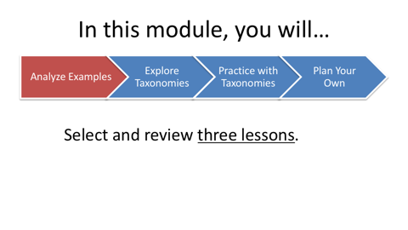  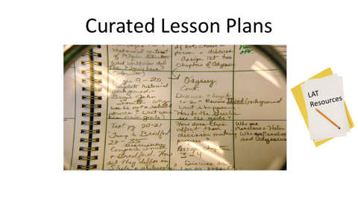 | In this module, you will be asked to select and review three lessons in your content area and approximate grade level that integrate technology to support teaching and learning.  We have curated collections of lesson plans that have been designed by preservice teachers like you. Links to these lesson plan documents are available on the LAT Short Course Resources document. Please feel free to use other resources, also.
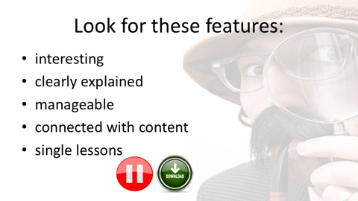 | When you are selecting lessons to examine, we suggest that you find ones that are interesting to you, clearly explained in considerable detail, and manageable in scope. Ideally, they should connect with the curriculum content and skills you will be teaching in the current or coming semester. For this step in the short course, it's probably better to choose single lessons rather than multi-day projects.  Please pause now to select and download three lessons to work with. You will annotate these in the steps that follow.
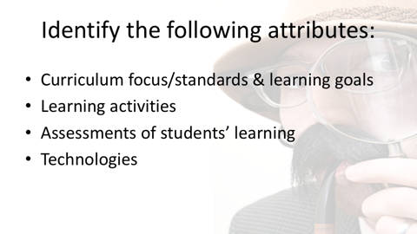   | As you read through each lesson, identify the following essential attributes. Add notes and/or comments in the lesson plan documents about the:  - Curriculum focus, standards, and learning goals around which the lesson is structured  - Learning activities in which the students will be engaged (Consider what the students - not the teacher – are doing in each phase of the lesson.)  - Assessments of students’ learning during the lesson - formally or informally - if any, and  - Technologies, both digital and non-digital, that are used in the lesson.  Examples of digital technologies include, for example, Web sites, software, and digital cameras. Examples of nondigital technologies include, for example, textbooks, paper notebooks, and whiteboards.
 | Now it’s time for you to annotate the three lessons that you selected and downloaded.  Microsoft Word’s highlighting and commenting features work well for this process. With the highlighter tool, you can use different colors to highlight different aspects of the design. For example, I’m using yellow to highlight the learning activities and green to highlight the digital and non-digital technologies in the lesson plan.  You can also add notes in the margins using the comment feature.
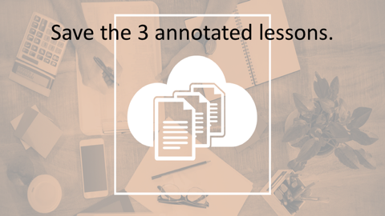 | Once you have selected, downloaded, annotated, and saved the three lessons, please put these documents aside for now. We will return to them soon.

