Module 3: Analyze Selected Existing Lessons
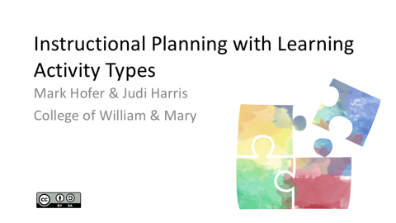  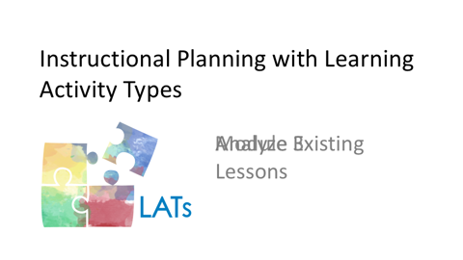 | All lessons, projects, and units are structured by combining and sequencing learning activities. Now that you have identified the essential attributes of the three lessons that you selected, let's think through how they are structured and how they make use of digital and nondigital technologies.
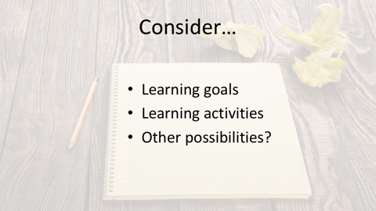   | Begin by reviewing the lessons’ learning goals. Then determine the degree to which you think that the learning activities that comprise them might assist students in meeting the goals. Are there other possibilities for learning activities that you think might work well in your classroom? If so, what would they be?  For example, might there be a way to make the lesson more student-centered, to add key pedagogical strategies from your curriculum area, or to better vary the ways in which students are asked to engage with what is being learned in the lesson? Following is an example of how a teacher could substitute other learning activity possibilities for those in an existing lesson plan.
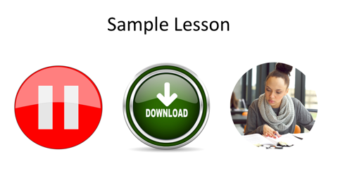 | To help you to understand this example, please pause to download the appropriate sample lesson plan from the LAT Resources document. Then read through the lesson plan so that you are familiar with how it is structured.
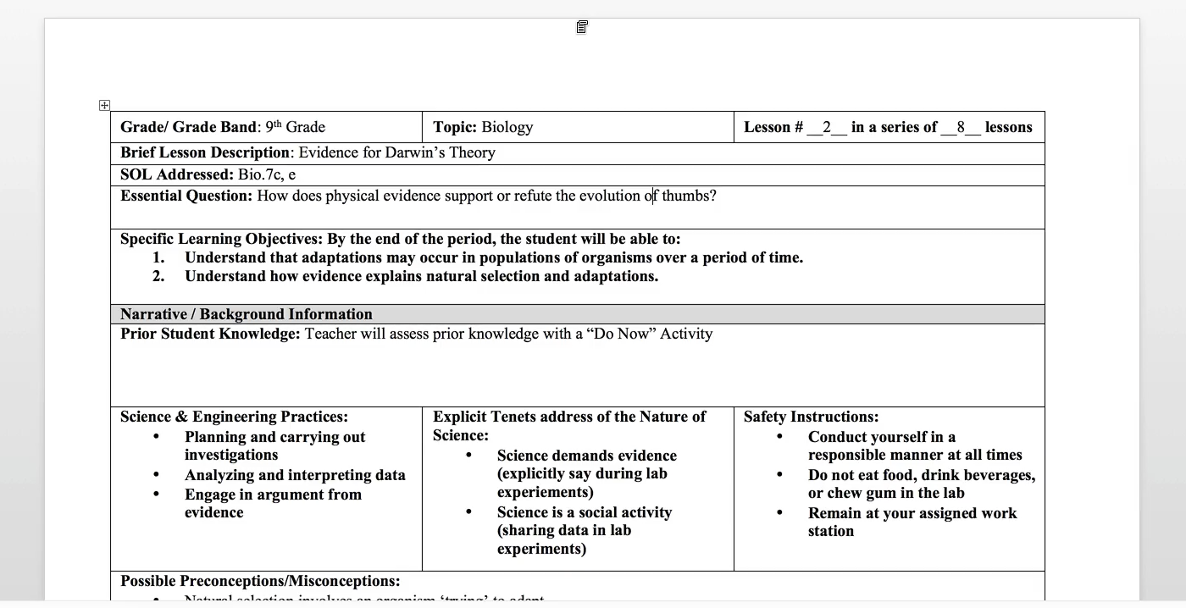  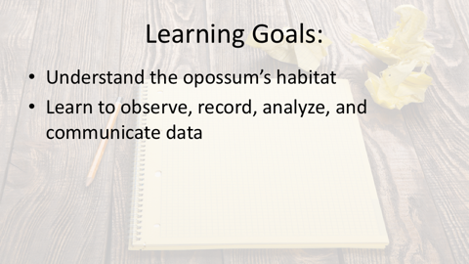  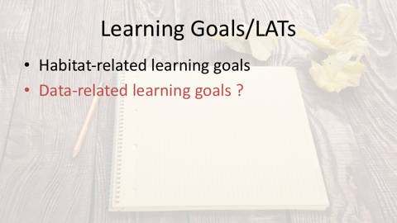 | In this first grade lesson plan created by a novice teacher, the students are learning about animal habitats. Specifically, they are developing the skills to observe, record, analyze and communicate data, and to explore and understand the needs of animals – in this case, the opossum. To work toward students mastering these learning goals, the teacher leads a discussion with the students about what makes their home a home. She then bridges to the characteristics of animal habitats – in part through the use of a brief video. This portion of the lesson concludes with the class developing a class chart about the opossum’s habitat. In the next phase of the lesson, students are provided with a box of materials and challenged to construct a model of the opossum’s habitat. The teacher then sets up their models as mock museum exhibits. Students then present their work to each other. Finally, as an extension, students formulate hypotheses about how opossums’ tails help them to survive.  Recall that the learning goals for this lesson were for students to understand the opossum’s habitat and also to learn to observe, record, analyze, and communicate data. In your opinion, which of these learning goals were addressed?  It appears that students would build their knowledge of animal habitats. We wonder whether the data-related learning goals were addressed sufficiently. If they weren’t, then the learning activities would need to be adjusted to help the students to meet these learning goals.
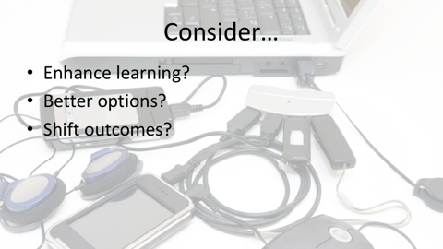 | Now, take a look at the particular technologies referenced in the lesson plan. To what degree do you think these technologies connect with, support, and/or enhance the learning activities? Are there other technologies that you think could be used in ways that better match the lesson’s learning goals? How might some of these changes shift the nature and learning outcomes of the lesson?
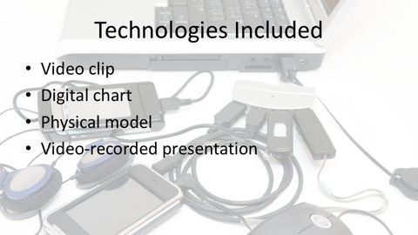  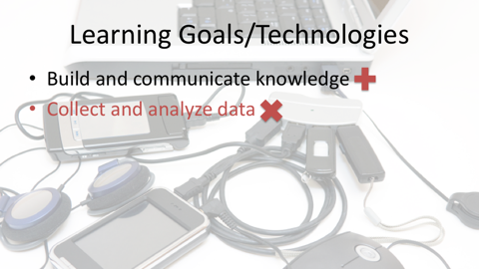 | In the habitats lesson we reviewed earlier, the lesson designer has incorporated a number of different technologies. The class views a video about the opossum’s habitat and contributes ideas to complete a digital chart. Then they use a collection of materials to create physical models of habitats. Finally, the teacher video records students’ presentations of their models.  The technologies in this lesson support students building and communicating knowledge about animal habitats. To better address the data-related learning goals for this lesson, a simplified spreadsheet could be used to help students to collect and analyze data about animal habitats.
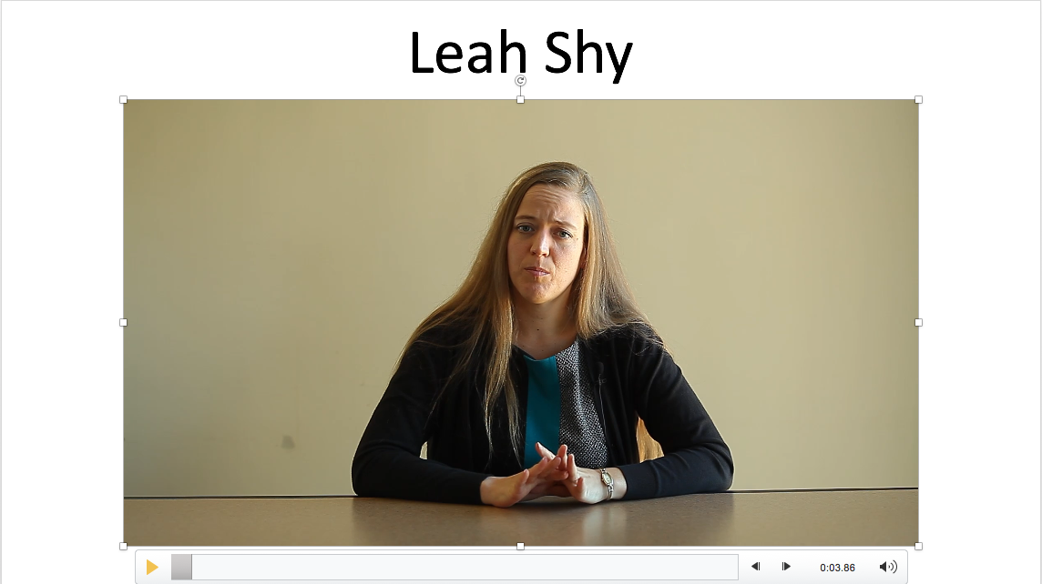 | Listen as Leah explains some of the educational technologies that she uses in her teaching most often. She also explains how the learning experiences change or are enhanced because of the ways in which the technologies are used.  Since all of my teaching experience has been in early elementary, in first and second grade, I feel like that has definitely shaped the educational technologies that I use.  I philosophically feel very strongly about developmentally appropriate practice and the importance of having students use things that they are capable and ready to use. So I think that definitely guides what I do use and what I don't use, both.  When I've had access to iPads at schools, I've found that they are much more intuitive and they are a much better tool than laptops or desktop computers for young children.  Especially now, where students have a lot of access to smartphones, tablets, things at home outside of school, it's much easier for them to navigate those and so if I'm using some sort of computer-based technology, I would prefer the iPads with the younger children.  When I find research that informs what I should or shouldn't be picking in terms of the appropriateness, I use that to guide me.  I also find that things that are easy to manage with a group are important. And I don't like management situations or decisions to always guide the instructional ones, but they have to be taken into account. So if I'm doing something that I want the students to be on iPads, I'm probably going to make that a small group activity so I can monitor it better, for example.  When I've had an interactive whiteboard in my classroom, I found that that's great for large groups. Children at that age love using those, it's engaging, there's so much that you can do with that both when you're presenting things to them and when they're sharing with you, in both ways. So I think that's something that I've used an awful lot.  I love the document camera. I feel like that's a really great way to be able to show student work right away and it honors what they're doing and is a way that you can demonstrate to the whole class something that usually you can't do just because of limitations of space. So that's a technology that I use a lot.
 | Please take a moment to think about connections among the learning goals, learning activities, and technologies incorporated in the lesson plans that you are analyzing. Please consider adding your questions and/or realizations in the Discussion area that your instructor has established. Please also feel free to respond to others' comments.

