Module 4: Explore Learning Activity Taxonomies
  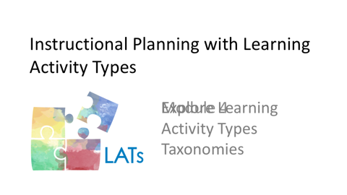 | As you noted during your exploration in the previous module, a sequence of learning activities, including assessments, comprise all lessons. How, though, do teachers determine which learning activities to include in their designs?
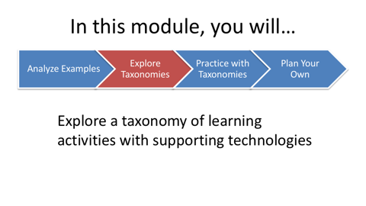 | In this module, you will explore a taxonomy of learning activities with supporting technologies. You can use these to revise or create effective learning experiences for your students.
   | As teachers, we tend to gravitate toward those learning activities that appeal to us, those which we have enjoyed most as students, those that we have found to be most successful as teachers, or those that we simply prefer for other reasons. These ways of selecting learning activities are unnecessarily limiting, however.  It's easy to overlook potentially effective learning activities with which we are less familiar or have simply forgotten. Considering a more comprehensive collection of learning activities during planning would be more effective.
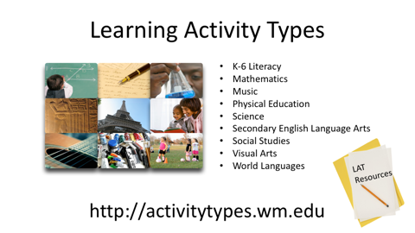 | We have collaborated with curriculum experts in nine different content areas to create comprehensive collections of possible learning activities in each. We then organized these learning activity types (or LATs) into categories and subcategories unique to each content area to make them easier for teachers to use in their planning.
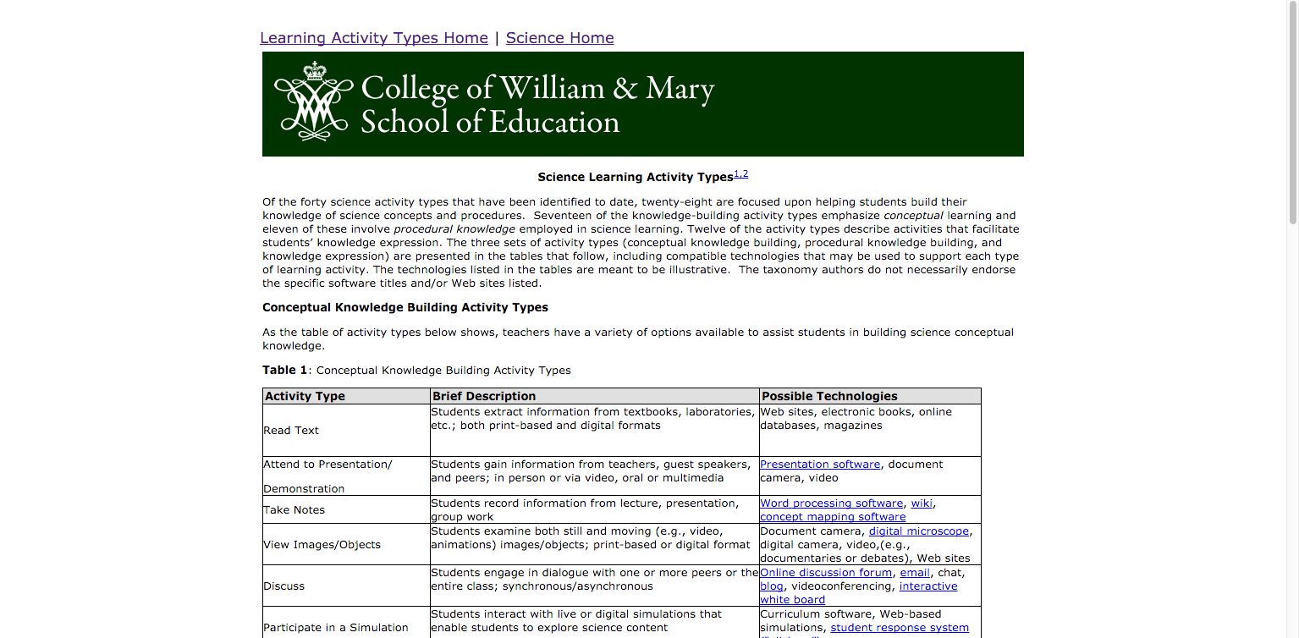 | For example, in the science taxonomy, the two primary learning activity types categories are knowledge building and knowledge expression. The knowledge building activity types are further subdivided into either conceptual or procedural knowledge building activities. Each of the taxonomies are similarly organized to make them easier for busy teachers use.  For each learning activity type or LAT, we offer both a description of the learning activity, and suggested educational technologies that can be used to support it.  The technologies included in the third columns of the taxonomies are not meant to be exhaustive. Instead, we hope that they can provide some initial ideas about technologies that can best support each LAT. Choosing appropriate educational technologies according to the goals of each learning activity can help to ensure that students’ curriculum-based learning is the primary focus for technology use.  Alternatively, when we choose learning activities according to which technologies we want to use, we place the quality and effectiveness of students’ learning at risk.
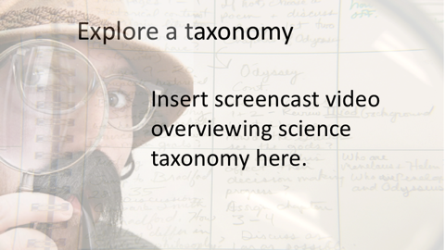  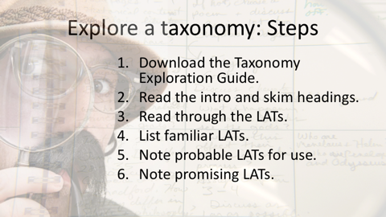 | Now it’s time for you to explore a taxonomy. Choose the one that is most relevant to your teaching assignment. (You can always explore other taxonomies of interest later.)  Please follow these steps as you explore this taxonomy.  - First, download the Taxonomy Exploration Guide from the LAT Short Course Resources document.  - When you first view the taxonomy, read the introductory text and skim the taxonomy to see how the LATs are organized into categories and sub-categories.  Now read through the learning activities in the different categories and subcategories.  - List the LATs that are familiar. From this list, *identify the particular LATs that you think you would probably use frequently.  - Now note the LATs that seem promising, but that you haven't had much experience using.  Keep your completed Taxonomy Exploration Guide to use in the next module. This module will help you to identify combinations of learning activities for the lesson that you will create.

