Module 5a: Practice Using the Taxonomy
  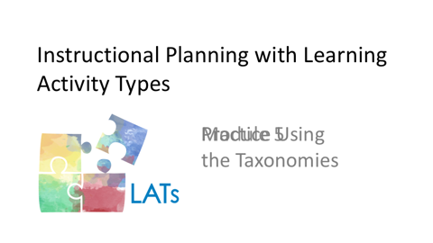  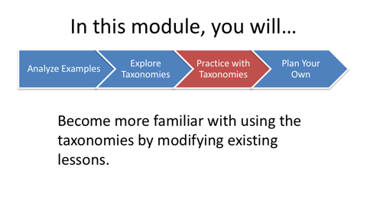 | One way to become more familiar with using the taxonomies for instructional planning is to modify existing lessons. To this end, we suggest you go back through each of the three lessons that you began exploring in module three. Now you will practice using the taxonomies to modify the learning activities embedded in these lessons.
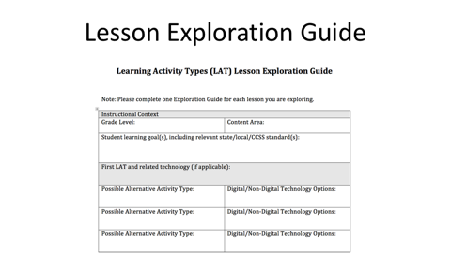  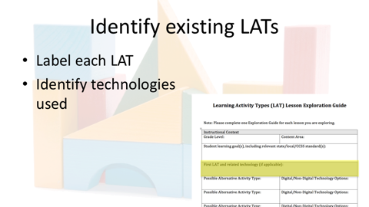 | To do this, please download the Lesson Exploration Guide using the link in the LAT Short Course Resources document.  Label each of the learning activities in the three lessons that you chose with learning activity names from the taxonomy that you’re working with. Please note that the lesson’s designer probably uses different terms than what appear in the taxonomy. Also note the particular digital and non-digital technologies used in the lessons. These technologies may not necessarily appear in the taxonomy. This is because the technologies included are meant to be illustrative rather than comprehensive.
 | Please pause here so that you can find and label the learning activities and accompanying technologies for each of the three lessons that you’ve selected.
SEPARATE MODULES 5A and 5B
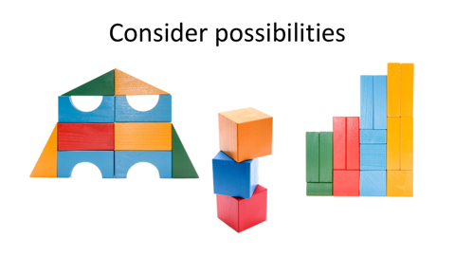  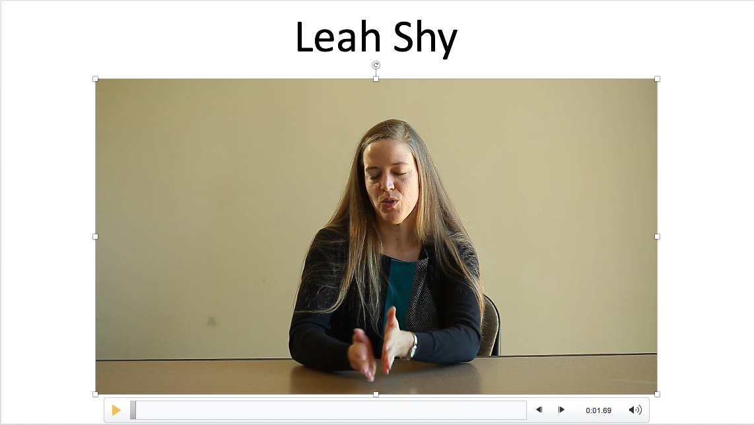 | Now that you have identified the existing learning activity types in the lessons you chose, you can begin to consider different learning activity types possibilities. Considering different learning activity type options is something that experienced teachers do during planning.  In the following segment, Leah explains how she goes about selecting and combining learning activities.  “Going back to what I previous said about always focusing on the learning outcome, I would start with ‘What’s the target that I’m trying to get students to learn?’ And then using the taxonomies—with that clearly in my mind—going in and saying, ‘Okay, what’s the skill that they’re working on?’  and then looking at ‘What are the resources that might be available to do this?’  “And I find that the process is kind of—sometimes it can be back and forth—that it’s not just linear, ‘Okay, this is what I’m going to use’ and then figure out an activity because sometimes you’ll choose something that works and then test it out and then as you’re planning realize that that activity might not be the best way so you kind of go back and say, ‘Okay, maybe there’s a different technology that would make this better.’  “And I feel that some of that is practice, quite honestly, you just have to do it. And sometimes you have to test out in the classroom to see what your students are prepared to be able to use and what you’re prepared to be able to teach with. And sometimes the refinement comes after if you’ve taught it. But I think figuring out, kind of, what combines, a lot of it is being able to go back and forth—focused on what the outcome is that you want to do—but going back and forth between what are the tools that I can use, what are the activities I can do, do these match up with the learning, and do I need to change, and being willing to adapt that as you plan.  “So one example is I planned a unit, the unit that was set for me. The grade level all did fairy tale writing in second grade and so I had an assumption that in second grade they would have some familiarity with fairy tales.  “So, I started right in on the writing unit beginning with looking at the elements of fairy tales and I expected that they would know enough fairy tales that they could work in small groups and come up with some of these elements and ideas from things that they knew but I realized that first day that a lot of the students simply didn’t have the background knowledge about fairy tales—which surprised me, but once I learned that, I knew that for future years, and I learned for that very unit I had to change what I did.  “So the next day, instead of continuing with this idea of fairy tale elements, the next day I immersed them in fairy tales and I brought in lots of books from the library and we talked about ones they knew and we started brainstorming and mapping out fairy tales that they were familiar with.  “I planned it in that I was going to read to them at least one fairy tale every day to give them that exposure. So I really had to change the approach because I had assumed that they had this background knowledge that in fact they didn’t have.”
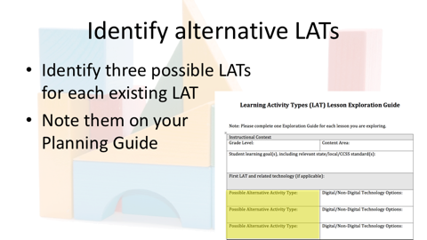 | Now that you’ve heard how an experienced teacher considers learning activity type possibilities in her planning, we will ask you to do something similar. Use the relevant LAT taxonomy to consider different learning activity options in the three lessons you’re working with.  For each learning activity type that you noted in the existing lessons, we encourage you to identify three possible alternate learning activity types, and *note them on the Lesson Exploration Guide.
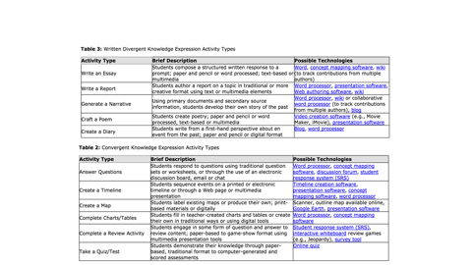 | To identify different activity type possibilities, examine others in the same category. You might consider LATs in other subcategories as well. As you think about LAT possibilities, consider how you might formatively and/or summatively assess your students’ progress in meeting the learning goals. Many LATs can serve both learning and assessment functions.
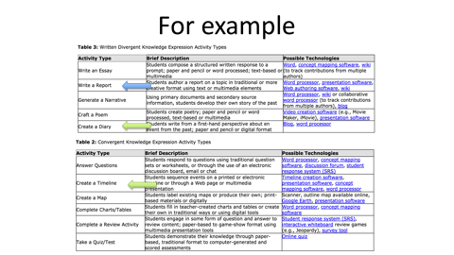 | For example, while students might demonstrate their knowledge of an historical concept through a written report, you might also consider having students create a diary entry from a particular point of view, or create a timeline to help illustrate a cause and effect relationship. Either of these LATs would provide rich information on your students’ progress in meeting the learning goals.
  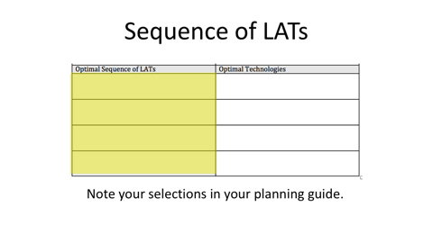 | As you weigh these possible substitutions, think about students completing the different types of activities. How might the "flavor" of the lesson and/or the quality of the students’ learning change? Please note that changing one LAT in a lesson may also necessitate changing or adding other LATs to create a coherent sequence for students’ learning.  For each segment of the lesson, identify an optimal combination and sequence of LATs. Note your selections in the Lesson Exploration Guide.
 | Please pause here so that you can construct alternate sequences of LATs for each of the three lessons that you’ve selected.
SEPARATE MODULES 5B and 5C
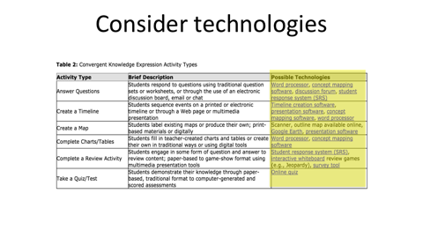   | Now its time to explore possible digital and nondigital technologies that could be used in the three alternative LAT sequences you constructed. For each of the LATs noted in three sequences you constructed, examine the suggested technologies listed in the corresponding taxonomy.  What changes might you make to the technologies to best support students’ learning with each LATs? How might adding, removing, or changing a particular technology change the lesson overall?
 | While making changes to the learning activity types and/or technologies, you may have noticed how changing one can necessitate changing others. Please take a moment to note any realizations that you’ve had about the interconnected nature of content, learning activities and technologies. Please consider posting these realizations in the Discussion area(s) for this module that your instructor has established. Please also feel free to respond to others’ realizations.

