Module 7: Lesson Design
  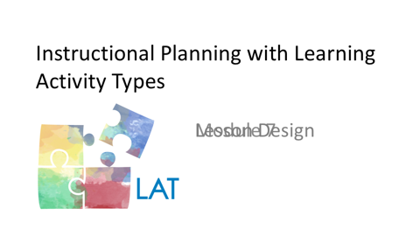  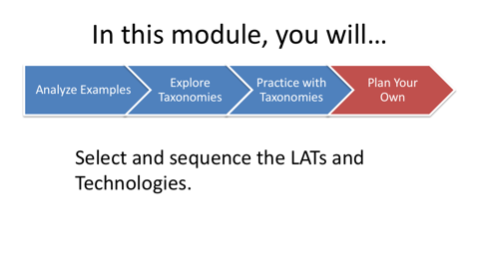 | In a previous module, you identified the learning goals for the lesson that you are planning. You also considered some of the contextual parameters that will inform how you approach the learning experience with your students. In this module, you will select and sequence the specific learning activity types that will provide structure for the lesson.
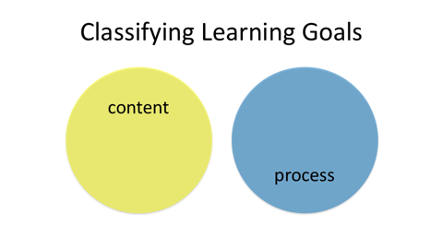 | When designing learning experiences, it can be helpful to classify the goals that you have identified. Some learning goals primarily emphasize content and others primarily emphasize process. Rarely would a lesson be structured completely around one or the other. More often, teachers combine content and process goals to create a richer, more well-rounded experience for their students.
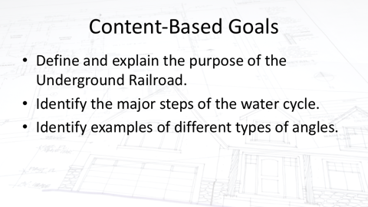 | Content goals help students to understand key concepts. For example, in a history lesson, students could be asked to define and explain the purpose of the Underground Railroad. In a science lesson, students might be challenged to identify the major steps of the water cycle and demonstrate how they are related to each other. In a math class, students could be asked to identify different types of interior angles and show how all change when one gets larger or smaller.
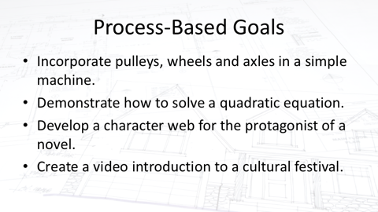 | Process goals are more action-oriented than content goals. They describe the skills, procedures and methods that students use in their learning. For example, in a science lesson students might be challenged to incorporate pulleys, wheels and axels in a single simple machine. In a math lesson, students might be asked to demonstrate how to solve a quadratic equation. In an English Language Arts lesson, students could be asked to develop a character web based on a novel’s protagonist. In a Spanish language class, students might be challenged to create a video-based introduction to a cultural festival.
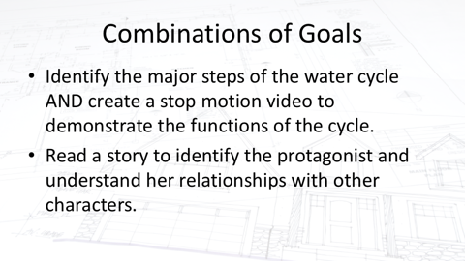 | Now think about how you might combine content and process goals into a single learning experience. For example, in addition to identifying the major steps in the water cycle, students might then be challenged to create a stop-motion video to illustrate how the cycle functions. Similarly, prior to creating the character web, students would read the story, identify the protagonist and understand her relationships with other characters in the story.
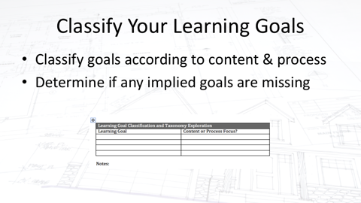 | With this in mind, please look back at the learning goals that you wrote in the previous and classify them primarily as content- or process-focused. If you have listed goals in only one of these classifications, please *think about whether there are any implied learning goals missing. If so, please add those unstated goals.  If students are asked to write a haiku, this would be an example of a process goal. In order to write it, however, they would first need to understand the form and features of haiku, which is a content goal. If you similarly identify any assumed content or process goals, note them in your Planning Guide.
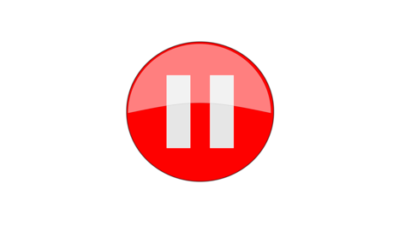 | Please pause here so that you can add this information to your Planning Guide before moving on to the next segment.
Split between 7a and 7b
 | JUDI - Veteran teachers draw on their experience to help them to select learning activities for their students. In this segment, you will learn a step-by-step process to select, combine and sequence learning activities for your lesson.  In order to determine the particular LATs that will comprise the lesson that you are designing, consider the experience from the perspectives of your students. Imagine that you will be a student working to meet the learning goals that you noted and classified earlier. What kinds of learning activities would be most appropriate?
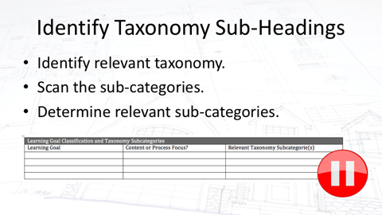  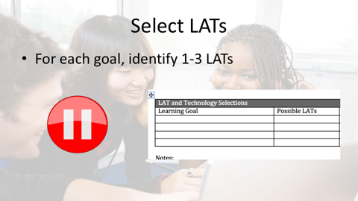 | Keeping the learning goals for your lesson in mind, find the one or two taxonomies that would best help you plan this lesson. Then scan the sub-categories within the taxonomies to determine those which are relevant to your planning. Please pause while you note the relevant sub-categories in your Planning Guide.  Now that you’ve identified the taxonomy sub-categories to use for each learning goal, choose multiple LATs that would help your students to meet that goal. Please pause while you list these possibilities for each goal in your planning guide.
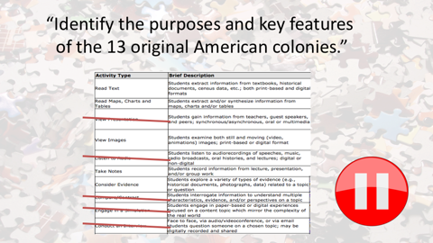 | Now that you’ve listed several possible LATs for each learning goal, it’s time to select the particular LATs that will best help students to meet those goals. With so many options available, this can be challenging. We will share an example to help to illustrate how you might go about this process. Consider for example, a lesson focused on helping students to identify the goals and key features of the thirteen original American colonies. Here are several knowledge building activities from the social studies taxonomy that could help students to meet this learning goal.  One way to select LATs that are the best fit is to eliminate those that don’t fit as well. One way to begin is to focus on the lesson’s content. Which of the possible LATs don’t match the content focus that well? For example, because the 13 original American colonies were founded in the 17th and 18th centuries, there are no audio recordings created at that time available to use in the lesson, so it makes sense to eliminate the “listen to audio” LAT. Note that the content of this learning goal is conceptualized at an introductory level. Games and simulations often require more background knowledge than this learning goal represents. *Therefore the game or simulation LAT would not be an appropriate choice for this particular learning goal. Finally, because of the early American history focus of the goal, it makes sense to eliminate the conduct-an-interview LAT, unless early American historians are available for the students to interview.  Learning activity choices can be further reduced by considering the overall learning experience that you are planning. If you are seeking to help your students to be more self-directed in their learning, you might consider eliminating having them view a didactic presentation. You might also consider eliminating a compare/contrast LAT that is similarly teacher-directed.  Please pause now so that you can reduce the LAT possibilities for each learning goal in your lesson.
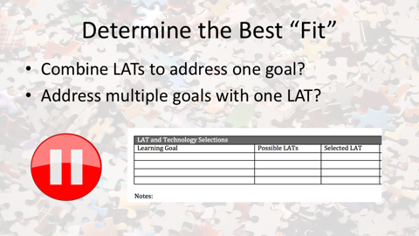 | Now that you have reduced the number of possible LATs for each of your learning goals, determine which of the LATs you feel are the best “fit” for helping students to meet each goal. Note that you may wish to combine multiple LATs to help students to address a single goal. A single LAT may also help students to meet more than one learning goal. Please pause to record these selections in your planning guide. Make sure that your list of learning activity types selections is finalized before proceeding to the next step.
 | Imagine again that you are one of your students who will be working with this combination of LATs during a lesson. Try to imagine what you, as a student, would experience as you engage with these learning activities.
 | Also, please consider discussing the advantages and disadvantages of your LAT choices with other classmates and teachers. Keep the contextual parameters that you specified in an earlier module in mind as you select these activities, too. Now – just one more time – check to make sure that these particular LATs would help the students to meet your lesson’s learning goals in the best ways possible. If not, consider other alternatives.
SPLIT BETWEEN 7B and 7C
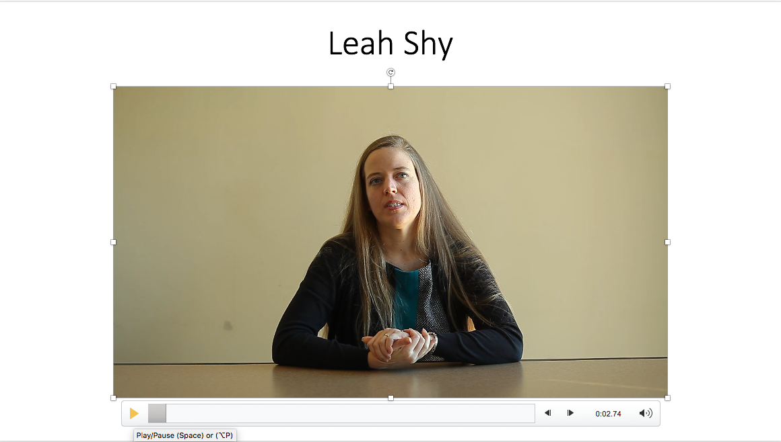 | Now that you have selected the specific LATs for your lesson, it’s time to sequence them. In this video, Leah describes how she goes about sequencing learning activities for her students.  “So, sequencing learning activities I guess first would be sequencing the objectives in terms of how they're scaffolded. What's the first thing that they need to know before they can go to the next thing before they can go to the next thing? So if I have the outcomes sequenced and scaffolded in a way that makes sense for students learning that's really building on itself, then it's much easier to fit in activities that will also be scaffolded and sequenced in a way that makes sense.  “Certainly I find that as I'm teaching sometimes I have to change those orders though because you realize from formative assessment that what you thought they knew they don't necessarily have. So sometimes you have to go back to reteach something or that what you think you need to teach you can actually skip that activity and go ahead because they already had it.  “So I think the theme of the sequencing has to be fluid, it has to be able to change depending on what your students need.  But I guess I don't actually sequence activities, I would sequence the learning outcomes and then select the activities in as they fit.”
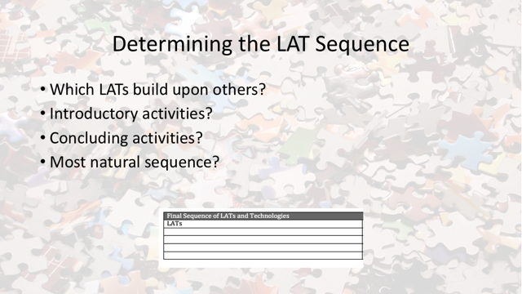 | To sequence learning activities, think about which LATs build upon others in your list. Which LATs would work best as introduction? Which LATs would work best as concluding activities? From the student’s point of view, try to determine the most natural sequence of learning activities to structure your final sequence of LATs.
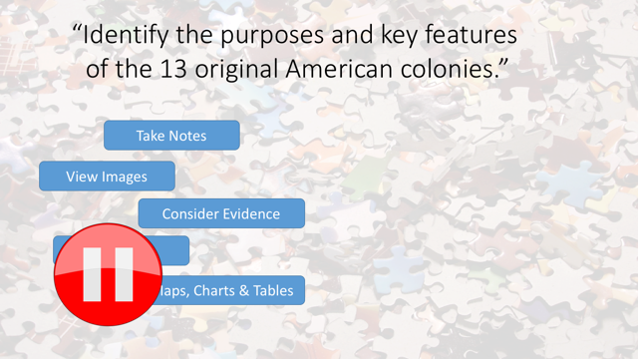 | For example, in the 13 American colonies lesson that was discussed earlier, after eliminating a number of possible LATs, five were selected. These are take notes, view images, consider evidence, read text, and read maps, charts and tables. The lesson could begin by showing students some intriguing images related to the colonies. Building on this, students could read text and read maps, charts and tables. Students may also consider evidence in the form of historical documents. As they are using these resources, they would also take notes. Considering this example, please pause here, work out the best sequence of learning activities for your lesson, and note them in your planning guide.
 | You may have noticed that we have not mentioned assessments to this point in the process of designing a lesson. This is not because planning assessment should occur separately from planning learning activities. Rather, the learning activities that you have selected for your plan often already include formative and/or summative assessment opportunities.
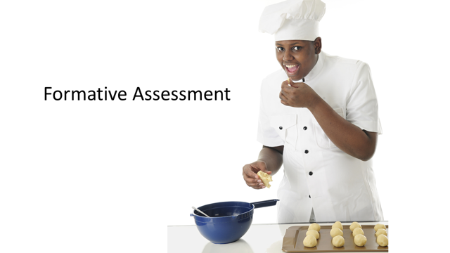 | Formative assessment is like when a chef tastes the food that he is preparing. He does this periodically to judge its quality, and can adjust ingredients and cooking processes as necessary. Formative assessment of students’ learning happens while the learning is taking place. Teachers often adjust learning activities based upon their formative assessments of students’ oral responses and written work.
 | Summative assessment is like when the chef sends the prepared food to the table of restaurant patrons. Their assessment of the quality of the food is final, and they can provide evaluative information via posts to social media or comments to their servers. Summative assessments of students’ learning can occur during activities such as quizzes, tests, presentations, and final evaluation of projects.
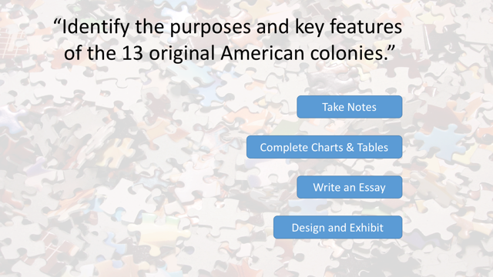 | For example, recall that the notes that students take in the 13 colonies example can serve as information for a formative assessment of their learning. One could also consider adding a summative assessment-focused LAT like completing charts or tables, writing an essay or designing and constructing an exhibit to assess students’ progress in meeting in the learning goal.
 | To ensure that you have included appropriate assessment-related LATs in your lesson plan, go back to your list and consider the ways in which you might gauge students’ progress in meeting the learning goals that you specified for your lesson. If you need additional assessments to determine this, please return to the taxonomy, select appropriate assessment LATs, and add them in appropriate places in the sequence that you have constructed.
 | Now please share this sequence with at least one classmate or colleague, explaining the content and process learning goals for the lesson. Ask your colleague for feedback on both the activity types selections and sequence, including what works well and what might be changed to make the lesson even more effective. Revise your LAT selections and/or sequence as needed.

