Lesson 8: Technology Selections
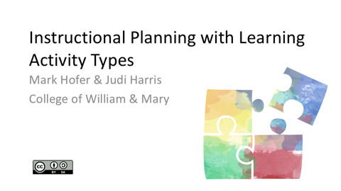  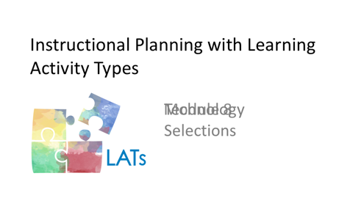  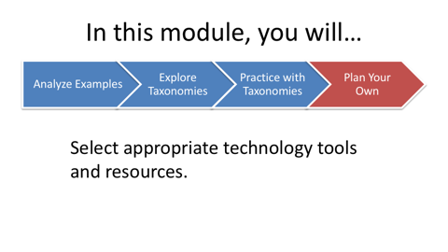 | After you have developed a promising sequence of learning activities for the lesson that you are designing, it’s time to consider technology possibilities. Some recommendations for appropriate digital tools and resources for each LAT appear in the third columns of the taxonomies.  Please note that you may not (in fact, probably should not) select a technology to support each LAT within the lesson that you are designing. There are many different factors to consider as you determine when and how to integrate technologies in your teaching. Most important of these are your students’ learning needs and preferences.
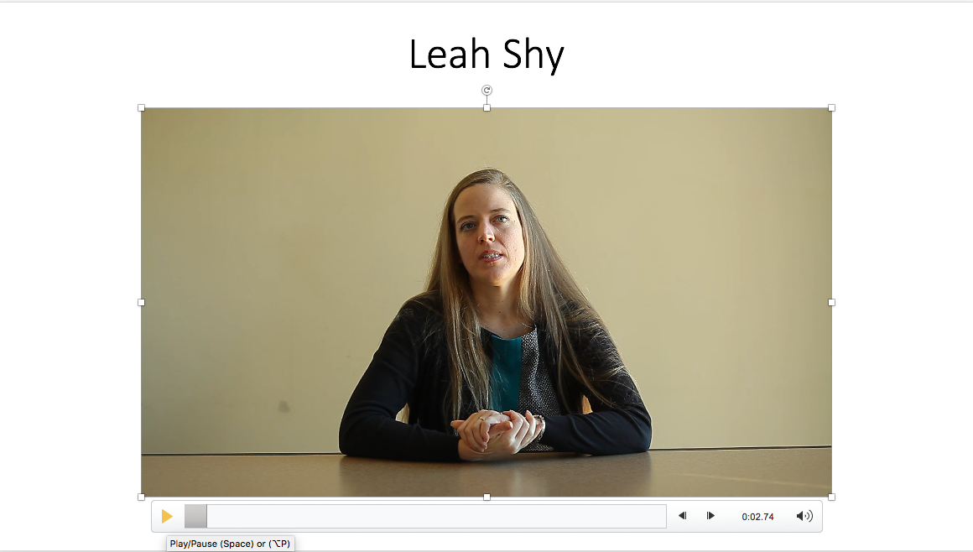 | In this video, Leah describes how her students used technologies effectively as part of a learning experience about publishing their work.
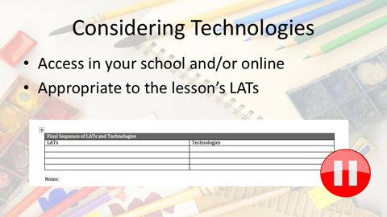 | When deciding which technologies to incorporate in your lesson, first consider which are available and easily accessible in your school and/or online. Then consider which of the available technologies are most appropriate for use within the particular learning activities you have selected and sequenced. Please pause here and list these appropriate and available technologies in your LAT Planning Guide document. Please note that you probably won’t include all of these possibilities in your final lesson design.
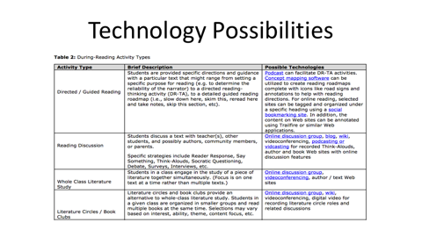 | Please note that the technologies suggested for each learning activity type in the taxonomies are not meant to be exhaustive lists. Instead, we hope that they will provide you with ideas for tools and resources to explore within your lesson.  If there are tools listed in the taxonomies that are not familiar to you, please consider clicking on the links provided to learn more about them. While you are exploring the tools, you may realize that one or more are not the best fit for the lesson that you are designing.
 | Once you have some technological options selected, consider the relative advantage of each tool to assist you in teaching the lesson. Which tools’ characteristics “fit” best what you want your students to do during the lesson that you’re planning?  Think about how well each technology that you’re considering "fits" with the curriculum focus, learning goals, and learning activities that comprise your emerging lesson plan. Your colleagues and mentors can be helpful in talking through the challenges and opportunities of different technological options.
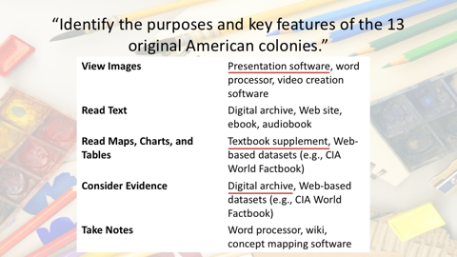 | For example, if we look back at the 13 American colonies lesson from the previous module, we can see that there are a number of technology possibilities for each of the LATs incorporated.  In the View Images activity, presentation software was used to show the class several high-quality images of historical drawings and paintings. This was intended to challenge some of the students’ previously held assumptions.  The students read text as they researched the purposes and key features of the colonies. While texts were available digitally, for efficiency, the students used their social studies textbook, supplemented with photocopied paper documents.  During the Read Maps activity, students did access digital resources. This was because the teacher realized the relative advantage of using curated historical Web sites. These sites offered the most illustrative and understandable maps for the lesson.  In the Consider Evidence activity, the students were challenged to find primary source documents that represent multiple perspectives and viewpoints. A digital archive can help make this process of locating documents more authentic, but still efficient enough for the students to use as part of their learning in the classroom.  During the lesson, students took notes in their paper notebooks, rather than with digital tools. In this example, the students used an analog tool instead because not all of them had easy access to a laptop, tablet or other digital device.
 | As this example demonstrates, choices of analog and/or digital tools are dependent on many factors. As you consider different technology possibilities, you can use a simple self-test to help you to decide which types of tools and resources to use. We call it the “Is It Worth It?” test.  Ask yourself three questions about each tool that you are considering:  - Will this particular use of a tool or resource help students to do something that is difficult or impossible to do without it?  - Will this tool or resource help students to do something in a better way?  - Is the use of this tool or resource feasible, given contextual conditions?  If your answers to all of these questions are “no,” then the technology choices should be reconsidered. If one or two of the answers is “no,” then reconsideration may be necessary.
 | In some cases, choosing not to use a technology may be the best pedagogical decision. In this video, Leah discusses an example of when she chose not to incorporate a particular technology in a lesson, why she made this decision, and what she helped students to do instead.
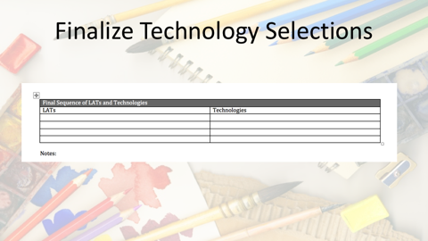 | Using what you’ve learned from Leah and the Is It Worth It? test, please finalize your selections of the specific tools and resources that you plan to incorporate in your lesson. Please note these selections in your LAT Planning Guide.
   | Now that all of the parts of your lesson have been assembled and sequenced, it’s time to do one final check. Earlier, you used the Is it worth it? test to determine when (and when not) to use particular technologies in your lesson.  Now we suggest that you perform a similar, but more comprehensive, self-test. This test will help you to ensure productive use of your students’ time and energy and a high quality learning experience. Ask yourself:  - Will this lesson design work, given all of the contextual factors that we discussed earlier?  - Is this lesson design appropriate for your students, given their learning needs, preferences, and developmental readiness?  Is this the best possible combination and sequence of learning activities and technologies to help your students meet the specified learning goals?  If your answer to any of these questions is “no,” then the lesson design needs revision. Talk with your colleagues and mentors for ideas on how to improve it.
 | We hope that completing these modules has helped you to know how to integrate technologies effectively into curriculum-based lessons.  As fellow teachers, though, we acknowledge that we can learn just as much or more from working with our students. So, as you implement the lesson you have planned, be open to new insights that you can glean from how your students respond to what you have designed.

